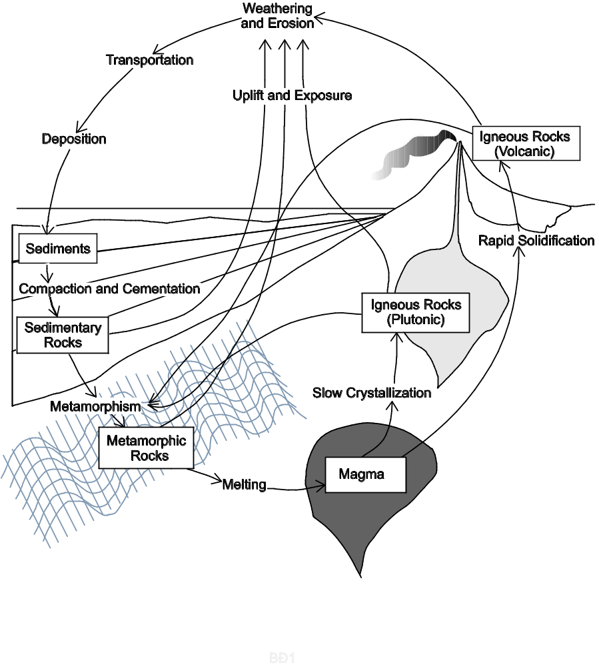

The Geological Definition of the Term Mineral
There are five characteristics that an Earth material must possess in order to be considered a mineral. Although what the book says is generally correct, I prefer my way of stating these characteristics. Please learn the five characteristics of a mineral as stated below.
For any earth material to be considered a mineral, it must exhibit ALL of the following characteristics:
a. It must be naturally occurring.
b. It must be inorganic (was never alive).
c. It must be a solid.
d. It must be crystalline; and all samples of the same mineral must have the same crystalline structure.
e. It must possess a definite chemical composition; and different samples of the same mineral may vary in chemical composition only within specified narrow limits.

Clarification of Terms
“Naturally occurring” means that it is not made by humans in a laboratory or factory.
“Inorganic” means that it is not made of organic molecules. When scientists call a substance “organic,” they mean that the substance is made of complex molecules composed primarily of carbon and hydrogen. Examples of organic substances include oil, protein, wood, and leaves. “Organic” substances are almost always made by living things. “Inorganic” substances are usually made by processes that do not involve living things, although they can be made by living things. Seashells, for example, are not considered “organic” because they are made of calcium carbonate, not carbon and hydrogen.
“Crystalline” means that the atoms that make up a mineral are always arranged in an orderly geometric pattern. The same mineral will always have the same geometric arrangement. To see examples of different types of crystalline structure, look at the illustrations of a single tetrahedron, single chains, double chains, and sheets in Figure 2.21 on p. 42.
“Definite chemical composition” means that, for two samples to be considered the same mineral, they must have similar (not necessarily identical) chemical compositions. Minerals typically have a range of compositions, but that range has limits. For example, olivine has a chemical composition of (Mg,Fe)2SiO4. What this means is that olivine is made of one silicon atom bonded to four oxygen atoms and two other atoms. Those two other atoms can be two magnesium atoms, two iron atoms, or one magnesium atom and one iron atom.
Bowen’s Reaction Series
Figure 3.13 on p. 61 of your textbook shows a very important diagram called “Bowen’s Reaction Series.” This diagram is based on a series of pioneering experiments conducted by a man named N. L. Bowen in the first quarter of the 20th century. He melted rocks and then studied them as they gradually cooled and crystallized.
This diagram summarizes a large amount of information in a simple visual way. It is similar to a graph. The middle part of the diagram shows a systematic arrangement of the nine basic minerals of igneous rocks. These minerals are
• olivine
• pyroxene (you didn’t study this mineral in lab; it closely resembles amphibole)
• amphibole
• biotite (black) mica
• calcium-rich (dark gray) plagioclase feldspar
• sodium-rich (white) plagioclase feldspar
• potassium (pink) feldspar
• muscovite (light-colored) mica.
• quartz
The systematic arrangement of these minerals on the diagram is based on the order in which they crystallize as a particular magma gradually cools. The minerals that crystallize first are plotted near the top of the chart and the minerals that crystallize last are plotted near the bottom of the chart.
Why would the minerals near the top of the chart crystallize first? Because they have the highest crystallization temperatures. Likewise, the minerals near the bottom of the chart crystallize last because they have they lowest crystallization temperatures. Minerals that crystallize at about the same temperature are shown side by side on the chart.
You may not be familiar with the term “crystallization temperature.” The term “melting temperature” may be more familiar. But they are really actually the same thing; the melting temperature of any substance is ALSO its crystallization (freezing) temperature. For example, whenever the temperature of pure water drops below 0°C (32°F), the water will crystallize and form ice; whenever the temperature of pure ice rises above 0°C (32°F), the ice will melt and form water. Keep in mind that, for igneous minerals, the range of temperatures we’re talking about is very high. The minerals near the top of the chart crystallize at temperatures over 1000°C (1800°F) whereas the “low”-melting temperature minerals near the bottom of the chart crystallize at temperatures around 700°C (1300°F).
Now let’s look at the diagram a bit more carefully. Note that each mineral is symbolized by an arrow or by a bar, not by a discrete point. What this tells us is that each mineral crystallizes over a range of temperatures, not at just one particular temperature. If you imagine any horizontal line straight across the chart, it will represent a particular temperature. All arrows or bars that this line crosses will correspond to minerals that can crystallize at that temperature. For example, amphibole, biotite mica and plagioclase feldspar can all crystallize at the same temperature.
What determines the melting temperature of a particular mineral? Everything else being equal, it is the chemical composition of a mineral that is the key deciding factor. Specifically…
• The higher the silica (SiO₂) content of a mineral, the lower is its melting temperature.
• The higher the iron (Fe) and/or magnesium (Mg) content of a mineral, the higher is its melting temperature.
• Plagioclase feldspar crystallizes over a wide range of temperatures, but the higher the calcium content (and lower the sodium content) of a feldspar, the higher the crystallization temperature will be.
Now, minerals that are high in silica tend to be low in iron and magnesium, and visa versa. As a result…
• Minerals that are high in silica and low in iron and magnesium are listed near the bottom of the Bowen’s Reaction Series chart.
• Minerals that are low in silica and high in iron and magnesium are listed near the top of the chart.
Recall from your lab on igneous rocks that felsic rocks are, by definition, high in silica and mafic rocks are, by definition, low in silica. Here is where the right side of the Bowen’s Reaction Series diagram comes in. Felsic rocks are made of minerals that are high in silica. So felsic rocks are made of the minerals listed near the bottom of the chart (feldspar, mica, quartz, and/or amphibole). Note that there is a “stripe” of a different color corresponding to each category of igneous rocks: felsic, intermediate (between felsic and mafic), mafic, and ultramafic (even lower in silica and higher in iron and magnesium than mafic—sort of like the term “extra-large”). To see which minerals can be found in any particular type of igneous rock, simply note the arrows or bars that are at least partially within the “stripe” for that category of igneous rock. Keep in mind that igneous rocks actually form a continuum of composition, ranging from 30-70% silica, and that the boundaries between categories (between felsic and intermediate, for example) are somewhat arbitrary.
What the Bowen’s Reaction Series diagram is NOT
It is very tempting, when first looking at the Bowen’s Reaction Series diagram, to incorrectly see it as a cross section of the Earth, showing a series of layers stacked on top of each other with the top layers near the surface and the bottom layers at great depth. This is NOT what the Bowen’s Reaction Series diagram is trying to show. This diagram puts the top “layer” on top in order to show that these rocks are made of minerals with high melting temperatures. The “layer” on the bottom shows rocks with low melting temperatures.
If you incorrectly see the Bowen’s Reaction Series diagram as a picture of Earth’s layers, you will be very confused because the diagram will seem to be upside down. You see, ultramafic rocks (shown at the top of the diagram) are extremely rare at the surface; almost all ultramafic rocks are found at depth in the mantle. Similarly, felsic rocks (shown at the bottom of the diagram) are extremely rare at mantle depths; felsic rocks are found almost exclusively in continental crust.
Minerals Formed By Chemical Precipitation
As stated on p. B–14 (Homework Assignment #4), one of the four basic residual products of weathering is chemicals dissolved in water. These chemicals do not remain in solution forever. For various reasons, they eventually “precipitate out” and form new minerals. These new minerals are usually quite different from the original minerals that weathered and produced the dissolved chemicals in the first place.
For example, when feldspar weathers, it transforms into clay minerals and dissolved chemicals: silica, potassium, sodium and/or calcium (see Table 4.1 on p. 89). The water that is carrying these chemicals usually flows downstream and makes its way to the ocean. Other minerals will weather to form, among other things, chloride ions dissolved in water. The water carrying these ions usually makes its way to the ocean too. The ocean, in fact, contains so many ions of sodium and chloride that it tastes very salty (table salt is sodium chloride). The sodium and chloride may precipitate out of the sea water and form crystals of the mineral halite (i.e. sodium chloride).
What could cause this to happen? The next three sections describe three processes that can cause chemicals to precipitate out of a solution: evaporation, cooling and the action of living things.

Chemical Precipitation Caused by Evaporation
When water evaporates from the ocean, it leaves any dissolved chemicals behind. Sometimes, especially in warm shallow ocean bays, a large proportion of the water evaporates, concentrating the dissolved chemicals in the remaining water. Eventually, the dissolved chemicals may become so concentrated that the water can no longer hold them all--it may become a supersaturated solution. As a result, various chemicals will precipitate out, forming crystals that settle to the ocean bottom. Almost all halite crystals form in this way.

Chemical Precipitation Caused by Cooling
Evaporation is not the only way that a solution of chemicals in water can become supersaturated. A temperature change can also do the trick. Warm water can usually hold more dissolved chemicals than cold water can. Thus a chemical solution that is unsaturated can become supersaturated just by decreasing its temperature. For example, hot springs produce hot water that contains various chemicals in solution. When that hot water cools off in the open air, the solution becomes supersaturated. As a result, various types of minerals precipitate, forming the white mineral deposits characteristic of hot springs.
A temperature drop can also cause minerals to precipitate in cracks or cavities under the ground. Most underground “open” spaces are filled with water that contains dissolved chemicals. This water doesn't stay put; it flows through the open spaces. As it does so, it sometimes cools and becomes oversaturated. It then precipitates some of its dissolved chemicals onto the walls of the open spaces. Most museum-quality mineral specimens were formed by this process--for various reasons, the crystallization process stopped before the open space was completely filled; thus the crystal forms of the minerals were preserved.

Chemical Precipitation Caused by the Action of Living Things
Living things, especially micro-organisms, are unimaginably abundant in rivers, lakes and the ocean. They “drink” the water and use the minerals that were dissolved in the water to make their shells, skeletons, cell walls, poop, etc. A great deal of calcite (calcium carbonate) is formed this way. When these creatures die, they settle to the bottom and form layers of chemical sediment.

Minerals Formed During Metamorphism
Rocks (and the minerals they are made of) are formed by a variety of processes under a variety of temperature, pressure and chemical conditions. Minerals are often stable only under the particular conditions that prevailed when and where they formed. If these conditions change, the minerals may become unstable and change to adjust to the new conditions. We have already seen that minerals that were formed at high temperatures or underground will weather when exposed to surface conditions. The weathering process converts minerals that are unstable at Earth's surface into minerals that are stable at Earth's surface.
Minerals can also undergo profound changes when they are subjected to conditions deep underground. We call these types of changes metamorphism. For example, sedimentary rocks, which form under low temperature and pressure conditions at Earth's surface, undergo metamorphism when they are buried deep underground where pressures and temperatures are high. Specifically, the original minerals in the sedimentary rock recrystallize to form new metamorphic minerals that are stable under the new conditions. During the process of recrystallization, the atoms and ions that make up the original minerals will actually re-arrange themselves into new crystalline structures and they will often migrate from one mineral grain to another, recombining in various ways. For example, iron may migrate from an iron oxide grain to a clay grain, combining with the ions in the clay to form mica. Thus the new minerals may have chemical compositions that are quite different from those of the original minerals. Strange as it may seem, this process can take place without melting or dissolving the original minerals. As you might imagine, metamorphic mineral growth takes a very long time.

Chapter 2: Minerals: Building Blocks of Rocks

Minerals: the Building Blocks of Rocks (p. 30–32); See also the section entitled “The Geological Definition of the Term Mineral” on p. B–3 of the course packet.

A. Minerals
1. Is a man-made diamond considered a mineral? Why or why not?

2. Is sugar considered a mineral? Why or why not?

3. Is table salt considered a mineral? Explain.

4. Can one sample of a mineral have a single chain structure and another sample of the same mineral have a double chain structure (See Figure 2.21 on p. 42)? Explain.

B. Rocks

1. What is the geological definition of a rock?

2. Can a rock be made just of one mineral?

3. “Most rocks occur as…” .

4. Can rocks be made of nonmineral matter? If not, explain why not. If so, list three examples.

Elements: Building Blocks of Minerals (p.32–33)
A. Minerals are made of elements. Are minerals made of just one element or many elements? Explain.

B. What is the smallest part of matter that retains the essential characteristics of an element?

Chapter 3: Rocks: Materials of the Solid Earth
Bowen's Reaction Series (Read the section entitled Bowen’s Reaction Series on p. B–4 to B–5 of the course packet. Also read How Different Igneous Rocks Form on p. 59–62 of the textbook and study Figure 3.13 on p. 61)
A. Sequence in which minerals crystallize from magma (Figure 3.13 on p. 61)

Questions to Answer
1. The Bowen's Reaction Series chart (Figure 3.13on p. 61) provides information about the minerals that are common in igneous rocks.
a. Which minerals are highest in silica, the minerals near the top of the chart or the minerals near the bottom of the chart?

b. Explain the reasoning behind your answer to question a above.

2. As magma gradually cools, why does the mineral olivine crystallize before any other minerals crystallize?

3. As magma gradually cools, why does the mineral quartz crystallize after all the other minerals have crystallized?

Classifying Igneous Rocks (p. 57–59 of the textbook and p. B–4 to B–5 in the course packet)
A. Igneous rocks are most often classified on the basis of their…
1.
2.

B. Characteristics of the rocks: See the following materials (1) p. B–4 and B–5 of the Supplementary Reading on Minerals (most important), (2) page B-45 of the course packet, (3) pages B–73 to B-76 of the course packet and (4) Figure 3.9 on p. 58 of the textbook.
1. Granitic (felsic) rocks--described near the left side of Figure 3.9

a. What three minerals are dominant?

b. Chemical composition (in comparison to mafic rocks)
The silica content of felsic rocks is high / low . (Circle the correct answer.)

c. % dark-colored minerals (see Fig. 3.9):

d. An extrusive (volcanic) felsic rock is called

e. An intrusive (plutonic) felsic rock is called
2. Basaltic (mafic) rocks--described near the right side of Figure 3.9

a. What two minerals are dominant?

b. Chemical composition (in comparison to felsic rocks):
High in .
(State names of elements, not names of minerals or rocks.)

c. % Dark-colored minerals (see Fig. 3.9):

d. An extrusive (volcanic) mafic rock is called

e. An intrusive (plutonic) mafic rock is called

3. Andesitic (Intermediate) rocks--described in the middle of Figure 3.9
a. What two minerals are dominant?

b. % Dark-colored minerals (see Fig. 3.9):
c. An extrusive (volcanic) intermediate rock is called
d. An intrusive (plutonic) intermediate rock is called
4. Ultramafic rocks—described on the far right part of Figure 3.9 on p. 58
a. What two minerals are dominant?

b. % Dark-colored minerals (see Fig. 3.9):
c. Ultramafic rock is believed to be a major constituent of which layer of Earth's interior?

Chapter 9: Volcanoes and Other Igneous Activity
A. Partial Melting (p. 271)--the crystallization series, run backwards

1. What is the important difference that “exists between the melting of a substance that consists of a single compound, such as ice, and melting igneous rocks, which are mixtures of several different minerals?”

2. As a rock is heated, which minerals melt first?

3. The silica content of any partial melt will be
higher than / lower than / the same as the silica content of the rock that is melting.
(Circle the correct answer.).

4. Do rocks usually melt completely or only partially?

B. Questions About The Types of Minerals Found in Volcanic Rocks in the Pacific Northwest:
The Juan-de-Fuca plate is currently subducting underneath the North American plate just offshore of northern California, Oregon and Washington (see Fig. 9.34E on p. 274 for an illustration of this process). This subduction is responsible for the scenic volcanoes of the Cascade Range (see Fig. 9.35 on p. 276). As oceanic lithosphere subducts, it releases water which buoyantly rises up into the overlying mantle. The addition of water to the ultramafic rock located there lowers its melting temperature. As a result, the ultramafic rock partially melts. The resulting magma migrates upward, “puddling” at the base of the crust and partially crystallizing (see Figure 9.34E on p. 274). The heat from this magma partially melts some diorite in the lower part of the crust, forming more magma. All of this magma can rise buoyantly through the crust and erupt out of volcanoes such as Shasta and Lassen.
Read Igneous Activity at Convergent Plate Boundaries on p. 272–273, Oceanic-Continental Convergence on p. 200–201, Magmatic Differentiation on p. 61–62 (especially Fig. 3.14), and Assimilation and Magma Mixing on p. 62. Also study Fig. 3.9 on p. 58 and Fig. 3.13 on p. 61. See p. B–4 and B–5 in this course packet for a detailed discussion of Fig. 3.13.
- What kind of magma is generated by the partial melting of the ultramafic (mantle) rock?

felsic / intermediate / mafic / ultramafic (circle the correct answer)

- Clearly explain why this kind of magma is generated by partial melting of ultramafic rock.

- As this magma rises, it often temporarily “puddles” near the base of the crust where it cools and partially crystallizes (see Figure 9.32 on p. 270 for an illustration of this). The crystals that form tend to settle to the bottom of the magma chamber, often staying behind as the remaining magma continues to rise up toward the surface.

a. During the process of crystal settling, the magma becomes richer / poorer in silica (Circle the correct answer.).

- As this magma cools, it also heats the intermediate-composition rocks of the lower crust and partially melts them. What type of magma is generated by partial melting of intermediate rock?

felsic / intermediate / mafic / ultramafic (circle the correct answer)

- Explain why this type of magma is generated by partial melting of intermediate rock.

- Both of the processes described in question #3 cause the magma that makes it all the way to Earth’s surface to be

higher / lower (circle the correct answer) in silica than was the original melt that formed in the mantle.
5. What kind of magma erupts from the volcanoes of the Cascade Range?

felsic / intermediate / mafic / ultramafic (circle ALL correct answers)

6. Explain why this type of magma erupts from the volcanoes of the Cascade Range.

7. What are the dominant minerals found in the volcanic rocks of the Cascade Range?
(Hint: To answer this question, use Table 3.9 on p. 58 and your answer to question #5 above)

Chapter 4: Weathering, Soil and Mass Wasting

Chemical Weathering (p. 88–90)
A. What is chemical weathering?

B. If a mineral is stable in the Earth's surface environment, will it chemically weather? Explain.

C. Water and Carbonic Acid
1. What is the most important agent of chemical weathering?
2. If a rock containing iron-rich minerals comes in contact with water full of dissolved oxygen, what will happen to the rock?

3. The action of carbon dioxide (CO2) dissolved in water (H2O):
a. What do you get when you dissolve carbon dioxide in water?

b. How, in nature, does carbon dioxide get dissolved in water?

D. How Granite Weathers
1. If feldspar comes in contact with carbonic acid, it chemically weathers. What are the most abundant products of the chemical breakdown of feldspar?

2. What other two products are produced during this process of chemical weathering?
a.
b.
3. When granite decomposes, what happens to the quartz that was in it?

E. Weathering of Silicate Minerals
When rocks chemically weather, their minerals are transformed into new substances. The “Mineral” column of Table 4.1 on page 89 lists several minerals common in igneous rocks. These are original unweathered minerals that, as a result of chemical weathering, are transformed into “Residual Products” and “Material in solution” (listed in the middle and right-hand columns of this table). Note that, when you get right down to it, no matter what mineral(s) you start out with, there are really only four basic products of chemical weathering.
What are the four basic products of chemical weathering? (Hint: the first one is listed for you)
1. Various chemicals in solution (i.e. dissolved in water), including silica, K⁺, Na⁺, Ca²⁺, Mg²⁺
2.
3.
4.

Supplementary Readings on Minerals

Minerals Formed by Chemical Precipitation (see p. B–6 to B–7 in course packet)
A. Water in lakes, rivers and the ocean always contains dissolved chemicals. Where did those chemicals come from in the first place?

B. Name and describe the three processes that can cause chemicals to precipitate out of a solution:

1.

2.

3.

Minerals Formed During Metamorphism (see p. B–8 in course packet)

A. When a rock undergoes metamorphism, why do the types of minerals in the rock often change?

B. When new minerals form in a metamorphic rock, the old minerals must first dissolve or melt.

The preceding statement is True / False (circle the correct answer)
Chapter 3: Rocks: Materials of the Solid Earth

Sedimentary Rocks: Compacted and Cemented Sediment (p. 62–70)
A. Introduction
1. What is the derivation of the word sedimentary?

2. Give four examples of sediment
a.
b.
c.
d.

3. The book states that “sedimentary rocks account for only about 5 percent (by volume) of the earth's outer 16 kilometers (10 miles). However…about 75 percent of all rock outcrops on the continents are sedimentary.” Explain how this could be true.

B. Classifying Sedimentary Rocks
1. Describe the two principal sources for materials accumulating as sediment.

a. Detrital Sediment:

b. Chemical Sediment:

2. Detrital Sedimentary Rocks (p. 64–65)
a. What are the two most abundant minerals in detrital sedimentary rock?
Mineral #1:
Mineral #2:
b. Why are these two minerals so abundant in detrital sedimentary rocks?

Mineral #1:

Mineral #2:

c. When we name detrital sedimentary rocks, what characteristic of the rock do we base the name on? (Be sure to study Figure 3.16 on p. 64)

d. Particle size and environment of deposition
i. The stronger the current (in air or water), the smaller / larger (circle the correct answer) the particle size carried by the current.

ii. In what kinds of environments are you likely to find gravels?

ii. In what kinds of environments are you likely to find sand?

iii. In what kinds of environments are you likely to find silts and clays?

3. Chemical Sedimentary Rocks (p. 65–67)
a. How is chemical sediment different from detrital sediment?

b. Example of deposition of chemical sediment by physical processes:

c. Example of deposition of chemical sediment through the life processes of organisms:

d. Limestone
i. What mineral is limestone composed of?

ii. Do most limestones form by direct precipitation from water or do most limestones form by biochemical processes? Explain.

e. Rock salt
i. What mineral is rock salt composed of?
ii. How does rock salt form?

f. What is the primary basis for distinguishing among different chemical sedimentary rocks? (Hint: See Figure 3.16 on p. 64.)

C. Lithification of Sediment (p. 67–69)
1. What is lithification?

2. Two major processes that cause lithification:
a. Compaction
i. What causes sediments to be compacted?

ii. As sediments are compacted, what happens to the volume of the sediments?

iii. What is happening inside the rock as this volume change occurs?

iv. For what type of sedimentary rock is compaction the most important process of lithification?
b. Cementation
i. How, in nature, is cementation accomplished?

ii. What are the most common natural cements?

D. Features of Sedimentary Rocks (p. 69–70)
1. Why are sedimentary rocks particularly important in the interpretation of earth history?

2. What is the “single most characteristic feature of sedimentary rocks” as seen in outcrop*, especially if the outcrop is large? (For illustrations of this “single most characteristic feature,” see p. 308–309 and Figure 11.3 on p. 313)

3. Describe two ways that fossils can be used to help us interpret earth's history from sedimentary rocks:

a.

b.

Chapter 5: Running Water and Groundwater

Earth as a System: The Hydrologic Cycle (p. 117–118)
A. Where is most water on earth found?

B. What energy source powers the hydrologic cycle?

C. Describe the hydrologic cycle (see Figure 5.3on p. 117). Be sure to include what happens when precipitation falls on land.

D. Earth's water balance: For the questions below, write in the appropriate mathematical symbol* in the blank provided

1. For the whole earth, precipitation evaporation.

2. On the continents precipitation evaporation.

3. Over the oceans precipitation evaporation.

E. Very little water is added to or taken away from Earth; the same water keeps circulating through the hydrologic cycle. Thus there must be an overall balance in evaporation and precipitation.
If precipitation and evaporation were the only two processes in the hydrologic cycle, the oceans would eventually run out of water and the land would be completely covered with water.
Describe an additional process which makes it possible for the hydrologic system to achieve balance.

F. How does the hydrologic cycle relate to the erosion and sculpting of the land surface?

Running Water (p. 118–119)
A. Where does the water in streams and rivers come from?

B. Streamflow: What force causes water to flow to the sea?

Thought Questions: The book does not directly address the questions below. Use what you have learned in this class to answer them.

A. List two ways in which the hydrologic cycle and the sedimentary part of the rock cycle are related.

B. The hydrologic cycle as described in the book and shown in Figure 5.3 (p. 117) is quite complete for short-term circulation of water (thousands of years or less). But there is also a long-term water circulation pattern that is left out of this depiction of the hydrologic cycle. When you studied igneous rocks, you learned that, in one major tectonic setting, water is very important to the igneous part of the rock cycle. Draw a diagram that shows how water goes deep into the earth and back out again over millions of years, playing a role in the igneous part of the rock cycle.
Chapter 4: Weathering, Soil and Mass Wasting

Debris Flow—also known as Mudflows (p. 109)
Mystery terms (You do not need to know these terms, but the book uses them so I have provided the definitions to help you understand what the book is trying to say):
Mass wasting is the down slope movement of rock, regolith and soil. Mass wasting is caused by gravity. Rock, regolith and soil will move down slope more easily if they are wet, so water is important to mass wasting but running water (i.e. in streams) is not involved.
Regolith is the layer of loose rock and mineral fragments produced by weathering.

A. Debris Flows in General
1. What is a debris flow? (In addition to reading the text, also study Figure 4.28C on p. 106 and Figure 4.24 on p. 104)

2. Are debris flows more common on ridges or in canyons? Explain.

B. Debris Flows in Semiarid Regions
1. Why are debris flows common in semiarid regions (like California)?

2. Describe a debris flow (What does it look like? What is it made of?).

3. Describe the consistency of the “mud” that is involved in debris (mud) flows.

C. Lahars (Volcanic Mud Flows)—p. 262
Many volcanoes, especially those that form at subduction zones, periodically erupt explosively. During an explosive eruption, the lava does not flow quietly out of the volcano; it sprays out as an explosive mist of tiny droplets moving at tremendous speeds. These droplets of lava solidify instantly and form a gray powder called volcanic ash. The 1980 eruption of Mt. St. Helens is an example of such an explosive eruption (see Figure 9.18 on p. 261 for a photograph of a cloud of ash racing down the slope of Mt. St. Helens). Volcanic ash is very fine, loosely packed and unstable and it can accumulate in very thick layers on steep slopes. Until the layers of ash on these slopes are compacted and/or stabilized with vegetation, they are perfectly suited for producing debris flows. Thus, in the weeks, months and even years after any major eruption of volcanic ash, lahars (volcanic mud flows) inevitably occur in the canyons that drain the volcano. See Figure 9.20 on p. 262 for a photograph of a lahar that occurred shortly after the eruption of Mt. St. Helens.
1. Describe how a lahar forms (see p. 262).

2. An explosive volcanic eruption, by itself, cannot trigger a lahar. Some other dramatic geologic event is also needed. Describe two such events than can help trigger lahars.

a.

b.

3. (Thought question--not covered by the book).
If you look at Figure 9.20 on p. 262, you can see that, wherever a debris flow stops, it forms a thick layer of sediment. New layers of sediment can then cover the debris flow and, eventually, the debris flow may lithify and become a sedimentary rock. How would you distinguish a sedimentary rock that was deposited as a debris flow from a sedimentary rock that was deposited as sediments settling to the bottom of a body of water?
Hint: running water will only deposit sediment while it is slowing down. The sedimentary particles that settle to the bottom will be those that are small enough to be carried by the flowing water at its old faster speed, but big enough that the flowing water can no longer carry them at its new slower speed. Thus the sedimentary particles deposited will all be about the same size.

Chapter 5: Running Water and Groundwater

Stream Channels (p. 124–126)
A. Big Chico Creek Canyon in Upper Bidwell Park is a(n) bedrock channel / alluvial channel .
(Circle the correct answer. Hint: if you aren’t sure, look at it on Google Earth.)
B. The Sacramento River west of Chico is a(n) bedrock channel / alluvial channel .
(Circle the correct answer. Hint: if you aren’t sure, look at it on Google Earth.)

C. Meandering Streams (See Fig. 5.12 on p. 125 for a photo of a typical meandering stream)
1. Where is the current moving fastest, on the outside of the meander bend or on the inside of the meander bend?
.

2. Erosion occurs on the outside / inside of the meander bend (circle the correct answer).

3. Thought Question: Clearly and fully explain your reasoning behind your answer to question 2. In order to write a complete answer, you will have to incorporate a concept that you learned in lab.

4. Sediment deposition occurs on the outside / inside of the meander bend (circle the correct answer).

5. Thought Question: Clearly and fully explain your reasoning behind your answer to question 4. In order to write a complete answer, you will have to incorporate a concept that you learned in lab.

D. Valley Widening (Page 128)
a. What is a flood plain and how does it form?

b. Why is a flood plain called a flood plain?

Groundwater: Water Beneath the Surface (p. 134–136)
A. Does groundwater typically flow in underground “rivers?” If so, explain what determines the locations of these rivers. If not, explain how ground water does flow.

B. The Importance of Groundwater: What percent of the world's fresh liquid water is ground water?

D. Groundwater's Geological Roles: Water plays a significant role in keeping rivers flowing during dry periods. Explain.

Distribution and Movement of Groundwater (p. 136–137)
A. How does water get into the ground?

B. Distribution
1. The Water Table: The book defines the water table as “the upper limit of” the zone of saturation. Translate this definition into ordinary language, focusing on how the rocks and sediments below the water table differ from those above the water table.

2. Is the water table perfectly level (horizontal)? Why or why not?

C. Factors Influencing the Storage and Movement of Groundwater: Porosity and Permeability
1. What is porosity?

2. What is permeability?

3. What two requirements must be met for a rock to be considered permeable?
a.
b.

4. Can a rock or sediment have a high porosity but a low permeability? Explain.

Springs (p. 138–139)
A. What is the relationship between the water table and a spring?

B. What is the source of the water that comes out of springs?

Chapter 3: Rocks: Materials of the Solid Earth

Metamorphic Rocks: New Rocks from Old (p. 70–75)
A. Introduction
1. What is the derivation of the word “metamorphism?”

2. Where and why does metamorphism take place? (Hint: it has to do with stability and instability)

3. Is melting involved in the formation of metamorphic rocks? Explain.

4. Describe the two settings in which most metamorphism occurs

a.

b.

B. What Drives Metamorphism? (p. 72–73)
1. Heat as a Metamorphic Agent
a. What is the most important agent of metamorphism? Why?

b. Describe two sources of heat to metamorphose rocks.

i.

ii.

2. Confining Pressure and Differential Stress as Metamorphic Agents
a. Confining pressure: Confining pressure is simply a function of depth. The deeper you go into Earth, the more rock there is above you and therefore the greater the pressure.
What two things does high confining pressure do to a rock?

i.

ii.

b. Differential Stress:

i. How is differential stress different from confining pressure?

ii. What does high differential stress do to a rock?

3. Chemically Active Fluids: How do chemically active fluids influence the metamorphic process?

C. Metamorphic Textures (p. 73–74)
1. At high metamorphic grades, the grain size (not the overall size) of a rock tends to
increase / decrease . (Circle the correct answer.) Explain.

2. Foliated Texture (Be sure to study Figure 3.29 on p. 73.)
a. What is a foliated texture and how does it form?

b. The rock below is foliated. Draw arrows to show the direction of the compressional force that acted on this rock to form a foliation.

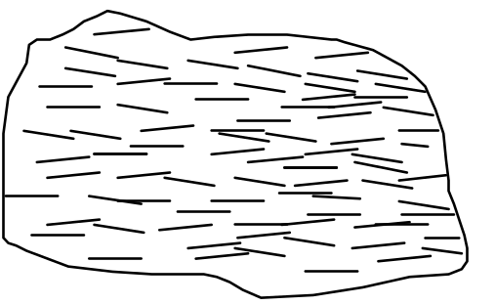

Introduction
Rocks are made of many mineral grains stuck together. These individual mineral grains range in size from microscopic to several feet in diameter. Unfortunately for earth scientists, most mineral grains are quite small (that's why they're called “grains”). In this lab, we will look at very large mineral grains and/or rocks made of small grains of just one mineral. These specimens will illustrate the basic physical properties of minerals exceptionally well. Once you have mastered the ability to identify the minerals in these exceptional specimens, you will learn to identify smaller mineral grains embedded in ordinary rocks. This skill is important because many rocks are classified by the minerals that they contain. We will spend two activity sessions on this lab.

Objectives

When you have completed this lab you should be able to
1. distinguish different kinds of minerals in the same rock.
2. determine the following types of physical properties of minerals: hardness, fracture, cleavage, streak, luster, reaction to acid, taste, and double refraction.
3. use these physical properties to identify 11 common minerals:
amphibole chlorite halite quartz
calcite feldspar iron oxides (rust) serpentine
clay garnet mica

Activity #1: Analysis of Cookies
The “ingredients” of rocks are called minerals. Some rocks are made of just one type of mineral, but most rocks are made of several different types of minerals, all jumbled together. To ease you into the process of distinguishing minerals in rocks, you will first analyze and distinguish the ingredients in something much more familiar to you--cookies.

Materials: 4 different cookies per group
tooth picks
paper towels

Activity:
1. Break each cookie into pieces so that each member of the group gets a piece of each cookie.
2. Use the toothpicks to carefully pick the cookies apart and analyze how the four cookies are similar and how they are different.

Questions:
1. Classify the cookies; i.e. give each cookie a name that clearly conveys what kind of cookie it is so that someone who couldn't see the cookie would instantly have a good understanding of what kind of cookie it is. Everyone in the group should agree to each of the names.
Cookie #1:
Cookie #2:
Cookie #3:
Cookie #4:

2. Write down all the ingredients that you think are in the cookies, including any ingredients you know are in there but you can't see.

3. Which ingredients can still be physically separated from the others? In other words, which ingredients still have their individual identities?

4. Apply this cookie analogy to rocks: Describe the relationships, in terms of “ingredients,” among rocks, minerals, and chemical elements.

5. Write down what you think might be the history of how the cookies were made. Include your best guesses as to when the cookies were made and what processes the ingredients went through to make the cookies.

Activity #2: Analysis of Two Igneous Rocks
Introduction: The basic “ingredients” of rocks are called minerals.
• All minerals have a crystalline structure. In other words, the atoms that make up minerals are arranged in regular geometric patterns.
• In all specimens of the same mineral (quartz, for example), the internal geometric arrangement of the atoms is the same. However, it is possible for the outsides of two crystals of the same mineral to have quite different shapes, especially if they bumped into other crystals as they grew (for example, not all quartz crystals have a perfect six-sided prism shape).
• All specimens of the same mineral have a similar chemical composition. That is, all minerals can be broken up into ingredients called “elements” (some examples of elements are silicon, oxygen, and iron). There is some variation in the numbers and kinds of elements that make up minerals, just as there is some variation in the ingredients in chocolate chips, but that variation is within a limited range.

Materials: Two igneous rocks, labeled “A” and “B”

Activity: Carefully examine the two rocks.

Questions:
1. Rocks A and B are both of the same type of igneous rock. What type of rock are they?

2. Are rocks A and B plutonic or volcanic?
How do you know?

3. Even though rocks A and B are similar enough to be considered the same type of rock, there are some differences. Describe these differences as clearly and accurately as you can.

4. Each rock contains three major types of minerals. Describe the color, shape and other characteristics of any major mineral(s) that the two rocks have in common:

5. Describe the color, shape and other characteristics of any major mineral(s) found in one of the rocks but not in the other.

Activity #3: First Attempt at Identifying Which Minerals are in a Rock

Materials: Two rocks, labeled “A” and “B”
12 minerals*, labeled as follows:
1) quartz 7) halite 13) chlorite
2) quartz 8) calcite 14) serpentine
3) quartz 9) calcite 15) amphibole
4) feldspar 10) clay 16) garnet
5) feldspar 11) mica 17) iron oxides (rust)
6) feldspar 12) mica 18) olivine

Activity: As best you can, match the three most common minerals in rocks A and B to the numbered mineral samples in the boxes. If you aren't sure (we fully expect you not to be sure at this point), list all of the possibilities.
Minerals in Rock A: 1.
2.
3.

Minerals in Rock B: 1.
2.
3.

Lab Activity #4: Refining Our Ability to Identify Minerals—Color
Background Information: Color is an obvious property of minerals, but it is generally not a reliable property to use for identification. Small amounts of impurities can change the color of a mineral, especially if the mineral tends to be clear when pure. For example, quartz can be clear, white, pink, purple, gray, black or almost any color you can think of. However, for some minerals, color doesn't vary much at all; so it can be safely used to help identify the mineral.
Activity: Note the colors of these minerals.

Mineral | Color
amphibole
chlorite
serpentine
olivine
Lab Activity #5: Refining Our Ability to Identify Minerals—Hardness
Background Information: Hardness is a measure of “scratchibility”. Diamonds are harder than glass; if you scrape a diamond across a piece of glass, the diamond will leave a scratch mark on the glass (so will many other minerals, as you will soon see). If you scrape a piece of glass across a diamond, the glass will powder and, perhaps, leave a mark; but that mark is easily rubbed off. Another effect of the differences in hardness is that the glass will skate easily across the diamond, whereas the diamond resists being scraped across the glass.
Materials: The minerals listed below
Piece of window glass (Hardness = 5.5)
Copper penny (Hardness = 3.0)
Fingernail (Hardness 2–2.5)
Activity: Following the step-by-step procedure described on the next page, determine the hardness of the minerals listed here. For these minerals, hardness is an important diagnostic property (i.e. a physical property that makes it easy to diagnose the presence of the mineral).

Mineral | Hardness |  | Mineral | Hardness
amphibole |  |  | halite
calcite |  |  | mica
clay |  |  | quartz
feldspar |  |  | serpentine
garnet
Step 1: Place the piece of glass flat on the lab table. With some pressure, drag the mineral specimen across the piece of glass. Rub off any powder that may have formed. If no mark remains, go to step 2. If a mark remains, the mineral has scratched the glass because it is harder than the glass; i.e. it has a hardness greater than 5.5. Write “> 5.5” on the appropriate line of the table above. Go on to the next specimen.
Step 2: If the specimen does not scratch the glass, the mineral is softer than glass and has a hardness of less than 5.5. Drag the mineral specimen across the copper penny. If the mineral fails to scratch the penny, go to step 3. If the mineral scratches the penny, its hardness is between that of a penny and a piece of glass (between 3 and 5.5). Write “between 3 and 5.5” on the appropriate line of the table above. Go on to the next specimen.
Step 3: If the mineral cannot scratch a penny, its hardness is less than 3. Try to scratch the mineral with your fingernail. If you're successful, the hardness of the specimen is less than 2.5. Write “<2.5” on the appropriate line of the table above. If you fail to scratch the specimen, its hardness is between 2.5 and 3. Write “between 2.5 and 3” on the appropriate line of the table above. Go on to the next specimen.
Question: Try to use hardness and color combined to narrow down your choices of the minerals that could be in rocks A and B? What possibilities have you eliminated?

Lab Activity #6: Refining Our Ability to Identify Minerals—How a Single Crystal of a Mineral Breaks (Cleavage vs. Fracture)

Background Information:
• Read about cleavage and fracture on p.37–38 in the textbook and study Figures 2.14 and 2.15.
• Watch the segment on cleavage in the videotape Rocks that Originate Underground.

Additional Information:
The concept of the characteristic cleavage of a mineral applies only to how a single crystal (or a fragment of a single crystal) behaves. For minerals such as clay, serpentine and iron oxides, which tend to form tiny microscopic crystals, the terms “cleavage” and “fracture” do not apply because we can't see how a single crystal breaks.
A mineral may cleave in some directions and fracture in others.
It is very easy to confuse cleavage surfaces (perfectly planar surfaces along which the crystal broke) with crystal faces (the edges of the crystal as it grew). Common minerals will have, at most, three cleavage directions. Those cleavage directions will generally form angles of around 60°, 90° or 120°. If there are three directions, those three directions will tend to form a box shape, never a pencil shape. In addition, a true cleavage surface will often have lots of surfaces parallel to it; all those surfaces will reflect light at the same angle, so that all those parallel surfaces will “light up” as you turn the mineral and catch the light at just the right angle.
Materials: Bulk unlabeled samples of quartz, halite and calcite (not the nice ones in the boxes)
Rock hammer
Goggles
Zip-loc bag
Labeled mineral specimens in boxes

Activity:
1. Obtain unlabeled samples of quartz, halite and calcite (Please do not bash the labeled samples in the boxes).
2. Examine and then break the unlabeled samples as follows:
a. Before you break each sample, sketch it in the appropriate box of the table on the next page, so that you remember what it looked like.
b. One at a time, place each mineral specimen in the Zip-loc bag and hit it with the rock hammer until it breaks.
c. Sketch the broken pieces in the appropriate box of the table below.
d. Describe how the mineral broke (did it cleave or fracture or both?)
e. Try to break one piece of each mineral again, in a different direction. Continue this process until you have determined the number of cleavage directions for each of the three minerals. Note the angles between the directions of cleavage (“90°” or “not 90°”).
3. Examine the mineral samples in the boxes, but don't break any of them. Most have already been broken. Describe any cleavage and/or fracture of each mineral listed in the tables. Fill in the appropriate boxes in the tables on the next page.
Question: Try to use color, hardness, cleavage or fracture to narrow down your choices of the minerals that could be in rocks A and B. What possibilities have you eliminated?

Bashing Unlabeled Bulk Mineral Specimens
 | “Before” Sketch | “After” Sketch | Does it cleave or not? | # of cleavage directions and angle between them  (“90°” or “not 90°”)
quartz
halite
calcite

Examining (No Bashing!) Labeled Mineral Specimens in Boxes
 | Does it cleave or not? | # of cleavage directions and angle between them  (“90°” or “not 90°”)
feldspar
mica
chlorite
amphibole

Lab Activity #7: Special Properties of Some Minerals

Materials Needed: • mineral specimens
• unglazed white ceramic tile
• small bottles of 10% hydrochloric acid
Procedure: For each mineral characteristic below, record your observations under “Luster” or “Other Characteristics,” as appropriate, on your mineral study sheets.

Luster: (See p. 35 in the textbook) Describe the luster of each mineral (suggested terms: glassy, dull, pearly) and record on the mineral study sheets.
Double Refraction: Place all of the clear specimens on a page of paper with writing on it. Look at the writing through the specimen and check for double images (caused by double refraction). Note any specimens that display double refraction.
Taste: Lightly place your tongue on the halite. Note its strong taste.
Reaction to Acid: Acid reacts with some minerals, vigorously dissolving them and releasing a gas. When we put acid on these minerals, we hear a fizz and see bubbles. Calcite is the only mineral in our boxes that reacts to acid. Place a drop of dilute hydrochloric acid on the calcite specimen that is milky (not the pretty clear one, please--you'll cloud it up); note the reaction.
Streak: (See p. 36 in the textbook) The only mineral in our boxes with a characteristic streak is the iron oxide. Rub the iron oxide over a white unglazed tile. Note the color of the powder.

Crystal Form: When a crystal grows freely without bumping into other nearby crystals, it develops a characteristic shape. Two of the mineral samples in the boxes have nicely formed crystals with characteristic shapes: quartz and garnet. Carefully examine your garnet and quartz samples and label each diagram on the right with the appropriate mineral name.
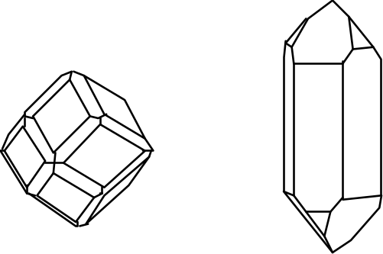

Lab Activity #8: Identifying Minerals in Rocks
Introduction: You now have a bag of tricks for using the physical properties of minerals to identify them. It is time to go back to the igneous rocks and use these physical properties to make certain that our identification of the minerals in rocks A and B is correct and to take on the more challenging task of identifying the minerals in rocks O and W (the other rocks are all too fine grained or too dark to pick out the minerals in them).

Activity: Identify the minerals in the igneous rocks A, B, O and W.

Minerals in Rock A: 1.
2.
3.

Minerals in Rock B: 1.
2.
3.

Minerals in Rock O: 1.
2.
3.
4.

Mineral in Rock W:

Lab Activity #9: Summarizing Mineral Properties
Complete one box (below and on the following pages) for each mineral you have studied.

Mineral Name:
Specimen #'s

Color(s):

Hardness:
Cleavage/Fracture:

Luster:
Other Characteristics:

Mineral Name:
Specimen #'s

Color(s):

Hardness:
Cleavage/Fracture:

Luster:
Other Characteristics:

Mineral Name:
Specimen #'s

Color(s):

Hardness:
Cleavage/Fracture:

Luster:
Other Characteristics:

Mineral Name:
Specimen #'s

Color(s):

Hardness:
Cleavage/Fracture:

Luster:
Other Characteristics:

Mineral Name:
Specimen #'s

Color(s):

Hardness:
Cleavage/Fracture:

Luster:
Other Characteristics:

Mineral Name:
Specimen #'s

Color(s):

Hardness:
Cleavage/Fracture:

Luster:
Other Characteristics:

Mineral Name:
Specimen #'s

Color(s):

Hardness:
Cleavage/Fracture:

Luster:
Other Characteristics:

Mineral Name:
Specimen #'s

Color(s):

Hardness:
Cleavage/Fracture:

Luster:
Other Characteristics:

Mineral Name:
Specimen #'s

Color(s):

Hardness:
Cleavage/Fracture:

Luster:
Other Characteristics:

Mineral Name:
Specimen #'s

Color(s):

Hardness:
Cleavage/Fracture:

Luster:
Other Characteristics:

Mineral Name:
Specimen #'s

Color(s):

Hardness:
Cleavage/Fracture:

Luster:
Other Characteristics:

Mineral Name:
Specimen #'s

Color(s):

Hardness:
Cleavage/Fracture:

Luster:
Other Characteristics:

Objectives
When you have completed this lab activity, you should be able to:
1. explain the essential difference between chemical sediment and detrital sediment.
2. describe how and why detrital sediment is deposited.
3. describe how and why chemical sediment are deposited.
4. explain how the speed of flowing water affects (a) the sizes of detrital sediment particles that the water can carry and (2) the sizes of detrital sediment particles that the water deposits.
5. explain why detrital sediment is often layered by particle size.
6. distinguish two very different mechanisms by which crystals can grow in a fluid.
7. explain how sediment is transported from far inland to the sea.
8. describe how running water can transform a featureless terrain into a complex landscape of ridges and valleys.
9. distinguish between erosion and deposition.
10. identify the following features of a river: tributaries, trunk stream, delta, distributaries
Important Definitions
Dissolved: a substance is dissolved in a fluid (liquid or gas) when its component ions, atoms or molecules have become separated and individually surrounded by molecules of the fluid.
Sediment: solid material that has settled to the ground or to the bottom of a body of water.
Chemical Sediment: Sediment that was once dissolved in water.
Detrital Sediment: Sediment that was never dissolved in water.

Activity #1: Chemical vs. Detrital Sediment
Materials: 1 clear plastic cup containing fine-grained halite (table salt)
1 clear plastic cup containing powdered clay
water
2 stirring rods
Prediction: Which do you think will dissolve in water: the salt, the clay, neither or both? Explain the reasoning behind your answer.

Activity: • Add water to each cup until it is approximately 2/3 full.
• Thoroughly stir the contents of each cup for at least a minute.
• Observe each cup right after you have finished stirring.
Questions:
1. Draw diagrams of the two cups immediately after you have finished stirring.

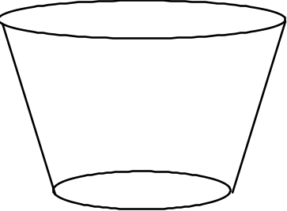

Water + Salt | Water + Clay

2. Which substance dissolved in the water: the clay, the salt, neither or both? Use your observations of the two cups to justify your answer.

More Activity: • Let the two cups rest undisturbed on the lab table for an hour or so.

More Questions:
3. Draw diagrams of the two cups after they have rested on the lab table for an hour or so.

Water + Salt | Water + Clay

4. Explain why the distribution of sediment in the two cups is so different.

5. Clay is a detrital / chemical sediment (circle the correct answer).
Salt is a detrital / chemical sediment (circle the correct answer).
Activity #2: Causing the Precipitation of Chemical Sediment from a Solution
Materials: salt water (solution of sodium chloride in water)
spoon
one glass Petri dish
10x magnification hand lenses
metal stand with a heat lamp on it, pointing down

Activity
1. Place a few spoonfuls of salt water into the Petri dish. Look at the solution with a hand lens. Draw a diagram of the Petri dish in the space provided below (Question 1).
2. Place the Petri dish under the heat lamp and let the water gradually evaporate. Go on and do Activities 3 and 4. After 10-15 minutes, examine the Petri dish and answer the questions below.

Questions:
1. Draw diagrams of the Petri dish, before and after the water evaporated.



Before Water Evaporated | After Water Evaporated

2. What caused the crystals to form in the Petri dish?

3. How is the process that formed these crystals fundamentally different from the process that formed the crystals of salol in the test tubes (you did this a couple of weeks ago)?

Activity #3: Studying the Deposition of Detrital Sediment
Materials: Mason jar with water and detrital sediment in it.
Dry detrital sediment: Mixture of gray pea gravel, fine white sand and a small amount of dark silt (the black "dirt" in central and western Chico is ideal).

Activity:
1. Shake the jar vigorously; the water picks up the detrital sediment, just as a flowing stream does.
2. Stop shaking the jar and watch what happens to the detrital sediment as the water slows down and comes to rest.
Questions:
1. What causes the detrital sediment to become suspended in the water?

2. What causes the detrital sediment to settle to the bottom of the jar?

3. Do the smallest grains land on the top or on the bottom of the layer? Why?

4. What is the important factor in determining which grains land on the bottom of the layer, their weight or their density? Why?
(Hint: what happens to the density of a large boulder when it's broken into small pieces?)

5. What natural river or ocean processes could result in the deposition of detrital sediment?

6. After most of the detrital sediment has settled, draw a diagram of the sediment in the jar, noting especially any variations in the size and/or color of the sedimentary particles.



More Activity: Open the top of the jar and add another 1/4 cup or so of sediment; watch it settle. Repeat several times. Note the layering; such layering is always present in sedimentary rock.

Questions:
7. Draw a diagram of the multiple layers of detrital sediment in the jar, noting especially any variations in size and/or color of the sediment.

8. Describe a natural scenario that could result in the deposition of distinct layers of detrital sediment.

Activity #4: Watching Running Water Modify a Landscape
Materials: 2 large plastic trays, each with a small hole in one end
small rubber stopper
moistened sediment (diatomaceous earth--the kind used for swimming pool filtration-- mixed with a small amount of fine sand)
flat plastic spatula
large (1 or 2 liter) plastic beaker
spray bottle full of water
sponge

Activity:
1. Initial set-up
a. The sediment in your tray should be pre-moistened. If it is not, ask your instructor to do it.
b. Plug the hole in the tray with the rubber stopper. Mix the moistened sediment well, using the plastic spatula and/or your hands. You will have to scrape the sediment off of the bottom using lots of elbow grease. Mix the sediment well until the sand (tan) is evenly distributed in the diatomaceous earth (white). If necessary, add some water until the sediment has the consistency of a mud pie.
c. Turn the empty tray upside down. Rest the tray containing the moistened sediment on the edge of the empty tray, with the plugged hole on the uphill side of the tray.
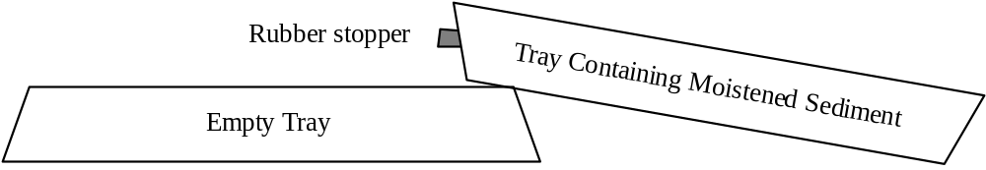
d. Push the sediment to the side of the tray opposite the hole. The sediment should cover about half of the bottom of the tray.
e. Firmly pat the sediment with your hands to make its upper surface as flat as possible (it will become very soupy when you do this).
f. Use the sponge to clean as much sediment as possible from the exposed bottom of the tray.

Comments: This is a small-scale model of a landscape. An inch on the model represents about a mile on a real landscape. A grain of sand represents a boulder. Regarding evolution of the landscape, one minute of the experiment is equivalent to about 1000 years in real life.
2. Running the Experiment:
a. Gently and slowly (so as not to disturb the sediment), place the tray of sediment flat on the upside-down tray.
b. Fill the plastic beaker with water and SLOWLY pour water into the sediment-free side of the tray just until there are no more dry spots on the bottom of the tray. This water represents the ocean; the sediment represents the land.
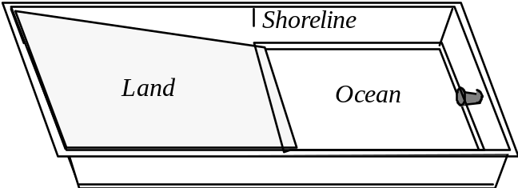
c. Watch as water drains off of the “land.” It will form several streams. At first, nothing may appear to be happening. Be patient and keep watching. Try to be the first in your group to see a stream appear.
d. Continue watching as the running water carves a landscape by eroding, transporting and depositing sediment. Be sure to watch what happens in the ocean as well as what happens on land.

Questions:
1. Where, in the model, is erosion occurring?

2. Where in the model is deposition occurring?

3. Explain the essential difference between erosion and deposition.

4. What is the predominant sediment that is eroded from the land, transported by the streams, and deposited into the ocean? The diatomaceous earth (white) or the sand (tan)? Why?

5. Is sediment deposited as one even layer in the ocean, or is more sediment deposited near the shoreline? Explain why this occurs.

More Activity: Continue Running the Experiment:
a. Gently spray a fine mist of water over the land (a few “squirts” should be enough)--you have just made it rain!
b. Watch the water run off the land. Notice how efficiently the streams channel the water from the land to the ocean.
c. Repeat several times, causing the landscape to continue to evolve.

More Questions
6. Does the upper surface of the sediment end up with coarser or finer sediment than it had when it started? Why does this happen? Draw diagrams to illustrate your answer.

7. If you drive south on Highway 99 from Chico, you see rolling hills covered with grass and thousands upon thousands of large boulders. The bedrock underneath these boulders is a sedimentary rock composed of mud- to boulder-size sediment. Use your answer to questions #1 and #3 above to formulate a hypothesis as to why the hills south of Chico are covered with boulders. (Hint: contrary to popular myth, these boulders were not thrown out of the Mt. Lassen volcano).

8. Draw a diagram of the final state of your experiment. Label the following features on your diagram: tributaries, trunk streams,2 meanders, deltas and distributaries.4

Remember to go back and finish Activities #1 and #2!
Objectives
When you have completed this lab you should be able to:
1. Identify five types of sedimentary rocks: conglomerate, sandstone, mudstone, limestone, and rock salt.
2. Identify some minerals in sedimentary rocks, especially quartz, clay, calcite, halite, and iron oxides.
3. Examine a sample of any of these rock types and tell the “story” of how it formed.
4. Identify three basic types of metamorphic rocks: quartzite, marble and schist.
5. Describe how foliation forms in metamorphic rocks.

Background Information About the Classification of Sedimentary Rocks

Sedimentary rocks are divided into two main categories: detrital (made of “bits and pieces of decomposed rock” that were never dissolved in water) and chemical (made of minerals that were once dissolved in water). Detrital sedimentary rocks are, in turn, classified by the size of the sediment it is made of—since sediment size is an indicator of the speed of the current that deposited the sediment. Chemical sedimentary rocks, on the other hand, are classified by the minerals they are made up of—since the mineral composition is an indicator of the chemical properties of the water from which the chemical sediment was deposited. The table on the next page summarizes the classification of sedimentary rocks.

Background Information About Depositional Environments

Sedimentary rocks contain a variety of clues that can help you figure out how and in what type of environment they were deposited. Here are some examples:
1) Sorting of Detrital Sediment: Sediment that was deposited on the bottom of a body of water is typically sorted by size (all the particles in each layer--which may be very thin--are about the same size) but sediment that was deposited as a mud flow is typically not sorted by size at all--boulders, pebbles, sand and clay particles are all jumbled together.

2) If detrital sediment is well-sorted by size, the sizes of the sediment particles provide clues as to how fast the water was flowing. The larger the particle size, the faster the water must have been flowing.

3) As detrital sediment is transported by flowing water, the sedimentary particles bang against each other and wear each other smooth, rounding any sharp edges. Thus the more rounded the grains of detrital sediment; the farther the sediment was transported.

Classification of Sedimentary Rocks

Detrital Sedimentary Rocks | Chemical Sedimentary Rocks
Made of detrital sediment--“Bits and pieces of decomposed rock” that were never dissolved in water | Made of chemical sediment--sediment that was once dissolved in water
Classified by size of sediment | Classified by mineralogy of sediment*
Classification  Sediment Size Rock Name  Gravel Conglomerate  Sand Sandstone  Mud Mudstone | Classification  Sediment Mineralogy Rock Name  Halite Rock Salt  Calcite** Limestone

*Halite and calcite dissolve much more readily in water than do most other minerals. Therefore, halite and calcite are common chemical sediments. For the same reason, detrital sediment is rarely composed of halite or calcite (one exception: gravel-sized pieces of limestone are common in desert environments where chemical weathering occurs very slowly).

**Most natural calcite is “biochemical” because it was initially removed from the water by water-dwelling organisms which used the calcite to make their shells or skeletons. When these organisms die, under the right conditions, these “hard parts” of their bodies accumulate as a layer of sediment.

Activity #1: Identification of Sedimentary Rocks
Materials: Sedimentary rocks labeled C, D, E, F, G, H, I, J, K, L, M, N
One hand lens per person
Mineral identification equipment (piece of glass, streak plate, acid bottle, penny)
7 pieces of 8.5" x 11" scrap paper
Activity:

1. Label the pieces of scrap paper and arrange them as shown here:
2. Using the Classification table above, sort the sedimentary rocks by type and place them on the appropriate pieces of paper.

Detrital |  | Chemical
Conglomerate |  | Limestone
Sandstone |  | Rock Salt
Mudstone

Question:
1. Write the name of each rock next to its letter:
C. I.
D. J.
E. K.
F. L.
G. M.
H. N.

Activity #2: Interpretation of Sedimentary Environment
Materials: Sedimentary rocks labeled C, D, E, F, G, H, I, J, K, L, M, N
One hand lens per person
Mineral identification equipment (piece of glass, streak plate, acid bottle, penny)
Activity: Read the “Background Information About Depositional Environments” at the beginning of this lab. Then examine the rocks as directed below and answer the questions about them.
Questions:
1. Closely examine rocks G and I. One of these rocks was deposited on the bottom of a body of flowing water. The other was deposited as a mud flow. Which is which? Explain the reasoning behind your answer.

2. Closely examine rocks H and F; be sure to look at them with a hand lens. Both rocks were deposited on the bottom of a body of flowing water. For which rock was the water flowing faster? Explain the reasoning behind your answer.

Activity #3: Identifying the Metamorphic Rocks
Background Information: There are only three basic types of metamorphic rocks that we will be studying in this class. These rocks are described in the table below.

Metamorphic Rock Identification Table
Name | Mineral Composition | Description | Parent Rock  (protolith)
Marble | Calcite | Made of light-colored crystals of calcite that are visible to the naked eye. Rock sparkles because the cleavage faces of the crystals reflect light. Can be foliated but the foliation is typically less obvious than it is in schist. | Limestone
Quartzite | Quartz | Looks grainy but has a slight waxy sheen. On some samples, the original sand grains are still visible. Can be foliated but the foliation is typically less obvious than it is in schist. | Quartz-rich Sandstone
Schist | Variable. Common minerals include chlorite, mica and garnet. Most common variety is composed primarily of mica and quartz. Flat sides of crystals are aligned. | Foliated (i.e. flat minerals oriented roughly the same way). Breaks into (sometimes bumpy) sheets parallel to foliation. | Usually mudstone, but can also derive from other rock types.
A. Materials: Metamorphic rocks: AA , BB, CC, DD, EE, FF, GG
B. Activity: Identify each rock; note the incredible variety of rocks that have the same name.

AA
BB
CC
DD
EE
FF
GG
Activity #4: Growth of Minerals During Metamorphism
A. Materials: Videotape Rocks that Originate Underground

B. Activity: Watch the segment on metamorphic rocks, especially the effect of heating on the steel wafer.

C. Questions:
1. What is happening to the molecules in the steel that allows the crystals to grow?

2. How are the changes in the steel similar to the changes in the metamorphic rocks?

Activity #5: Formation of Foliation During Metamorphism
A. Materials: Plastalena clay with glitter mixed in it; one piece per person.
Piece of schist (yes, really!)--Rock GG
You will use the clay-glitter mixture to model the behavior of solid rock as it forms a rock like GG. The glitter represents mica and the clay represents quartz. The clay is much easier to mold than real quartz is; so you can accomplish in a few minutes what it takes Mother Nature millions of years to do.

B. Activity: Work the clay, in any way you wish, to make the glitter particles line up with each other so that the clay/glitter mixture looks like rock GG.

C. Questions:
1. What natural processes could accomplish the same result in rocks?

2. Which of the metamorphic rocks (AA, BB, CC, DD, EE, FF, and GG) are foliated?

Dates/Times: See your syllabus for dates. Note that lab will run an extra hour on field trip day; please plan carefully for this. Specifically,
• 9–11 labs meet an hour early, at 8 a.m.
•12–2 labs meet an hour early, at 11 a.m.
•11–1 labs go an hour late, until 2 p.m.
• 2-4 labs go an hour late, until 5 p.m.
Place: We will meet at the bus-loading zone on the east side of Holt Hall, across from the Bidwell Mansion (the same place here BIOL 342 meets for field trips). We will be going to Bear Hole in Upper Bidwell Park (see map on next page).
What to Bring: Be prepared for rough trails and a short but steep uphill hike. Bring…
• This lab and a clipboard or other hard surface to write on.
• pencil
• water (the MOST important thing--you will be miserable without it)
• hat (light colors are best) to protect your head from the sun and to keep you cool; a baseball cap is fine but a visor will not do. VERY IMPORTANT! If you do not wear a hat, you will be EXTREMELY hot and miserable. There is no shade out there--don't forget your hat!
• sturdy shoes (hiking boots and athletic shoes are best; sandals, flats, & high heels will NOT do)
• sunglasses
• camera (optional)

Objectives
The primary purpose of this field trip is to see geology at its most real--in context instead of isolated in the lab--all around you instead of just in front of you. Secondary objectives include…
• to learn a little about topographic maps.
• to see several major rock formations of the Chico area.
• to identify rocks in outcrop.
• to understand where Chico's municipal water supply comes from.
• to use geologic reasoning to figure out how this area has changed over time.
• to get outside and have a good time.
Map to Bear Hole in Upper Bidwell Park
Driving Directions:
• From campus, take 2nd St. east; follow it across Big Chico Creek as it turns into Vallambrosa.
• Continue to follow Vallambrosa until it ends at Manzanita Ave.
• Turn left onto Manzanita Ave.
• Pass the Hooker Oak recreation area on your right; cross a bridge (over the Lindo Channel).
• Turn right onto Wildwood Ave., the entrance to Upper Bidwell Park (marked by a large wood sign).
• Follow the park road past the golf course and through a gate.
• Continue 2 miles past the end of the pavement; turn right into the Bear Hole parking lot.

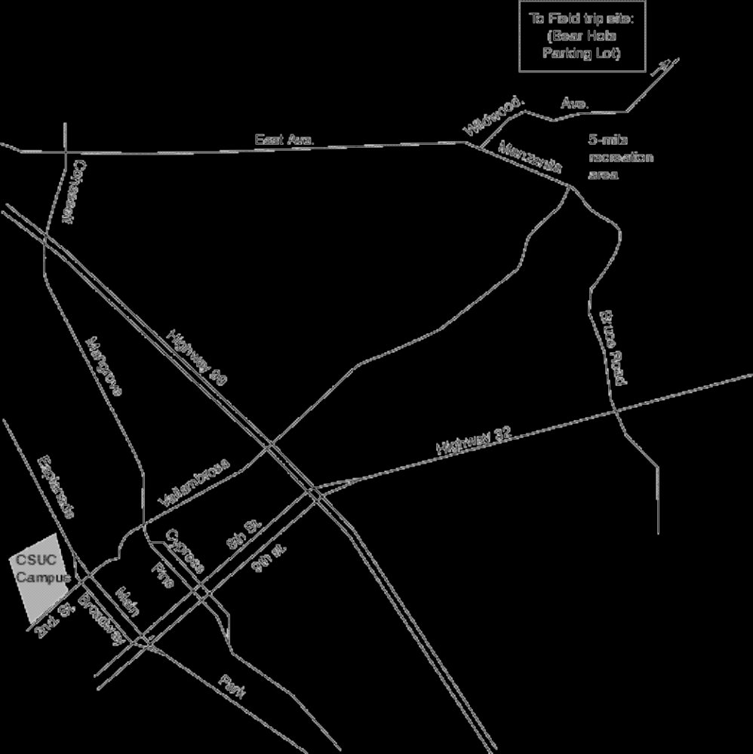
Stop #1 (Bear Hole Parking Lot): Introduction to the Topographic Map
Examine your topographic map of the Bear Hole area (on the back page of this lab). The gray lines that wiggle all over the map are topographic contour lines. Each topographic contour line connects points of a certain elevation above sea level. If you were to walk along one of these lines, you would never go up hill or down hill. To help you keep track of all these lines, every fifth contour line is extra thick. Only the extra thick lines are labeled but you can determine the exact elevation of each line if you know the contour interval, the vertical drop (or climb) between two contour lines.

1. Find the Bear Hole parking lot on the topographic map; plot your location (label it Stop #1) on the map.
2. Determine your elevation .

3. Wherever topographic contour lines are close together, the slope of the land is steep / gentle (circle the correct answer).

4. Wherever topographic contour lines are far apart, the slope of the land is steep / gentle (circle the correct answer).

5. Look across the creek and up to the cliff on the top of the ridge. Find that cliff on the topographic map. Circle the spot on the map that represents the cliff. How do you know, from the map, that this is a cliff?

6. Notice that each topographic contour line forms a “V” where it crosses Big Chico Creek.

a. The point of each “V” points upstream / downstream (circle the correct answer).

b. Could you start from here and cross the creek without ever going uphill or downhill? If not, why not? If so, what route would you take? Draw a diagram to illustrate your answer.

Walk down to the creek and follow the trail (an old flume) a little ways upstream.

Stop #2 (Bear Hole itself): The smooth black rock
7. Plot the location of Stop #2 on the topographic map.
8. This rock type is called the Lovejoy Formation and it is about 16 million years old. What kind of rock is this?

9. This rock is igneous / sedimentary / metamorphic. (Circle the correct answer.)

10. How did this rock form?

11. Note the vertical cracks in the rock (see diagram). They formed at the same time that the rock formed; in fact, they are characteristic of this type of rock. What made these cracks form?

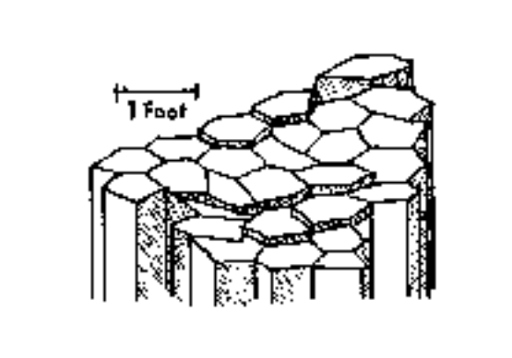
(Source of Diagram: Guyton and DeCourten, 1978, p. 6)

Return to the parking lot and follow a trail downstream until you reach some creek-side outcrops that are clearly not the smooth black rock.

Stop #3 (Downstream from Bear Hole): A Different Type of Rock

12. Plot the location of Stop #3 on the topographic map.
13. The rocks you see here are an outcrop of a layer in a sedimentary rock unit called the Tuscan Formation. Describe this outcrop by answering the following questions:
a. What size(s) of sedimentary “particles” make up this rock (boulders, gravel, sand, mud)?

b. What kind of rock is this?

c. The sedimentary particles in these rocks are well-sorted by size / poorly sorted by size. (Circle the correct answer.)
Note: To be considered well-sorted, all of the particles in any one layer must be about the same size; there can be major sediment size differences between layers.
d. The edges of the sedimentary particles in this rock are
somewhat angular / very worn and smoothly rounded. (Circle the correct answer.)
e. Some of the sedimentary particles are pieces of rock. What kinds of rocks can you identify (We're looking for names of rocks here, not minerals)?

f. Which of these rock types is the most common?
g. Are any of the sedimentary particles in this rock actually pieces of the smooth black rock you saw at the last stop? Explain.
Note: Not all rocks of the same type are alike. For example, some sandstones are made of 100% quartz grains and some sandstones have no quartz grains at all. Just because two rocks are of the same type does not mean that they are identical.

14. Based on your answers to #13 above, make some interpretations of the way these sediments were deposited and in what kind of environment they were deposited. Do this by answering the following questions:
a. Was this sediment deposited on the bottom of a body of water or was it deposited as a debris flow ? What evidence led you to this conclusion?

b. If you could go back in time and stand on this spot right after this sediment was deposited, what kind of landform (canyon, mountain range, volcano, ocean, lake, or river) would you see in the distance if you looked toward the northeast? Explain the reasoning behind your answer. Draw a diagram to illustrate your answer.

c. What kind of major geologic event(s) may have triggered the transportation and deposition of this sediment? Explain.

Follow the creek upstream until you reach the contact between the Lovejoy Formation and the Tuscan Formation.

Stop #4 (Located Between Stops 2 and 3):
The Contact Between the Tuscan Formation and the Lovejoy Formation

15. Plot the location of Stop #4 on the topographic map.

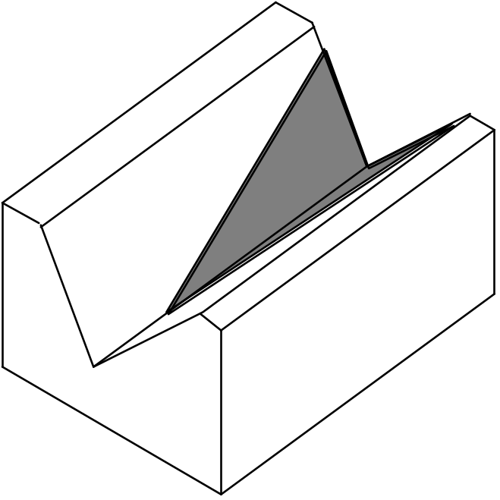
16. Which rock unit is older, the Tuscan Formation or the Lovejoy Formation? How do you know? To illustrate your answer, label each formation and draw in the layers on the side and front of the block diagram below.

Follow a trail back uphill. Stop where the trail begins to level out and turn to the right (where the trees meet the grass lands). There's a small outcrop on the right.

Stop #5: The Nomlaki Tuff, A Special Layer within the Tuscan Formation

17. Plot the location of Stop #5 on the topographic map.

18. The rocks cropping out here are part of the Nomlaki Tuff. This rock layer crumbles easily. Pick up some pieces of this crumbled rock and examine them. Describe its characteristics.

19. What type of geologic event was responsible for forming this layer?

Return to the parking lot and walk along the driveway back to the main park road. Cross the road and walk uphill, through the grass and weeds, to a large prominent gray rock outcrop (visible from the road--when you get to it, it will be about twice as tall as you are).

Stop #6 (After a long hard uphill hike): A Cliff Formed by a Fourth Type of Rock

20. Plot the location of Stop #6 on the topographic map.

21. These rocks form layers within the Tuscan Formation. In fact, the Tuscan Formation is made of alternating layers of the type of rock that you saw at Stop #3 and these types of rocks. However, the rocks at this location have a very different origin than the rocks at Stop #3.
a. What size(s) of sedimentary “particles” make up these rock layers (boulders, gravel, sand, mud)?

b. The rock layers exposed here are just two basic sedimentary rock types. What are these rock types?

c. The sedimentary particles in these rocks are well-sorted by size / poorly sorted by size. (Circle the correct answer.)
Note: To be considered well-sorted, all of the particles within any one layer must be about the same size; there can be major sediment size differences between layers.
d. The edges of the sedimentary particles in this rock are
somewhat angular / very worn and smoothly rounded. (Circle the correct answer.)
e. Some of the sedimentary particles are pieces of rock. What kinds of rocks can you identify (We're looking for names of rocks here, not minerals)?

f. Which of these rock types is the most common?

22. Based on your answers to #21 above, make some interpretations of the way these sediments were deposited and in what kind of environment they were deposited. Do this by answering the following questions:
a. “These layers of sediment were deposited on the bottom of a body of water.”
Describe specific evidence for this statement and how this evidence can be used to show that the statement is true.

b. In what kind of body of water were these sediments deposited (circle the correct answer)?
ocean / lake / river in a narrow valley / river in a wide flat valley
Explain the evidence and reasoning behind your answer.

c. If you could go back in time to when these sediments were being deposited, you would not be able to see the rocks at Stops 1, 2, 3 and 4. Explain why you would not be able to see them. Draw a diagram to illustrate your answer.

23. The rock layer we are standing next to is an excellent aquifer - a layer that can hold a lot of ground water and that allows ground water to flow through it easily. Chico's drinking water is pumped out of wells that tap layers just like this one, hundreds of feet below the city of Chico (see diagram).
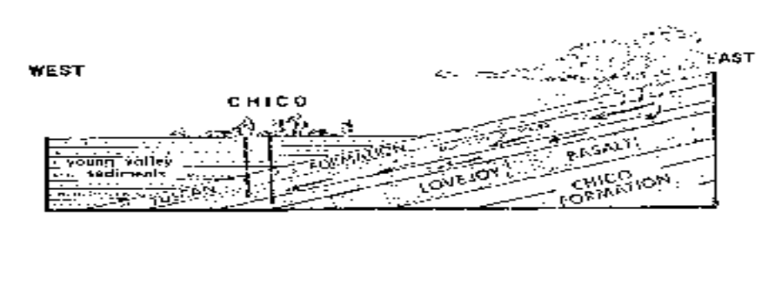
(Source of Diagram: Guyton and DeCourten, 1978, p. 12)
a. The source of our drinking water is rain falling here, in the hills east of town where these layers are exposed at the surface. How does the water get from here to the wells?

b. Why does this water flow westward, toward Chico, instead of flowing straight down? To illustrate your answer, add to the diagram on the previous page.
(Hint: Do you think that the Lovejoy Formation is a good aquifer?)

24. A few years ago, there was a big controversy about housing development in “Bidwell Ranch,” the land immediately north of Upper Bidwell Park. What do you suppose will happen to the quality and quantity of Chico's water supply if major development is allowed at Bidwell Ranch?

Return to the Bear Hole Parking Lot (Stop #1)

Second Visit to Stop #1: The Bear Hole Parking Lot

25. Look across the creek and notice several areas of bright-green vegetation. The plants in these spots are fresh and green, even in late summer when it hasn't rained for months and all of the other vegetation in the area is brown. Obviously, there must be some source of water in these spots that lasts all year.
a. Where is this water coming from?

b. Why is there water year round in these few spots but not everywhere? In other words, what is special about these areas? To illustrate your answer, add to the diagram below.
(Hint: What kinds of rocks make up the bedrock in these locations?)

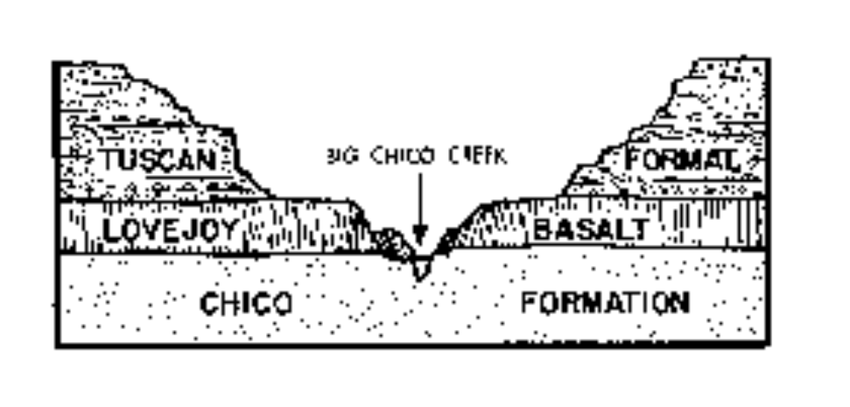
(Source of Diagram: Guyton and DeCourten, 1978, p. 9)

Reference (Optional): Introduction to the Geology of Bidwell Park, by J.W. Guyton and F.L. DeCourten: University Foundation, CSU Chico, 1978. This book is on reserve in the library and available for $2 at the Bidwell Mansion visitor center.
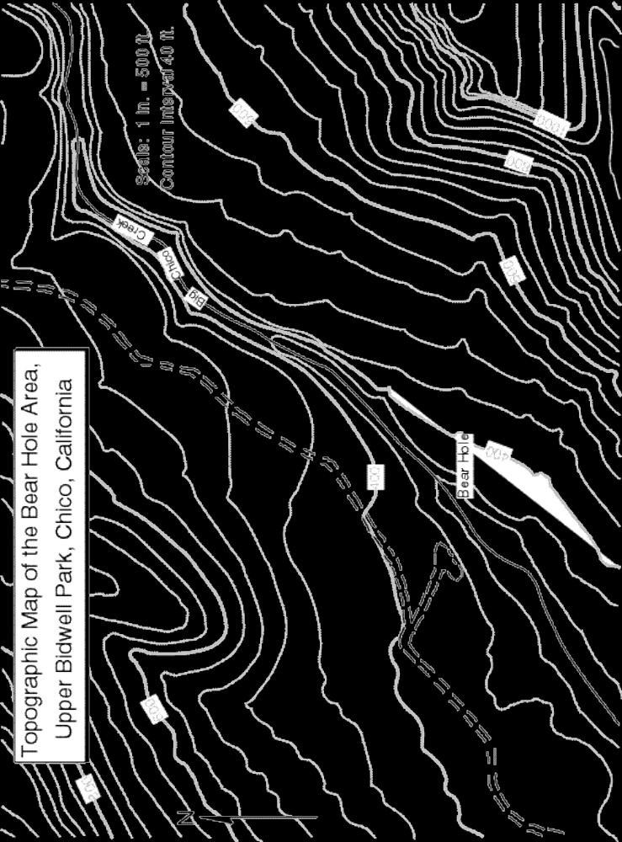

I. Making New Minerals by Melting and Crystallizing Magma
A. Analyzing the Bowen's Reaction Series Chart (See also Fig. 3.13 on p. 61 of the textbook.)
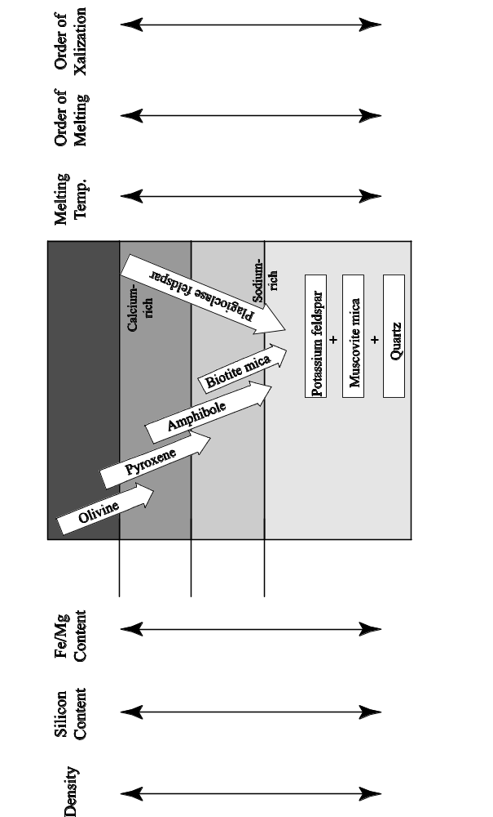
B. Why are there different kinds of igneous rocks with different kinds of minerals in them?

C. Rocks never fully melt; they partially melt. What happens as a rock partially melts?
1. Ice, butter and cheese analogy:
a. Mix cubes of ice, butter and cheese together, add a little water and put this mixture in the freezer. You have made a “rock.”
b. Put this fake rock in a bowl in the refrigerator.
What melts?
What does not melt?
c. How would the melt be different from the original “rock?”

2. Partial melting of real rocks
a. What melts? What doesn't?

b. How is the melt different from the original rock?

3. Cooling and solidification of the melt:
After the melt cools and solidifies into rock, how is that new igneous rock different from the rock that originally melted?

4. Specific Implication for the generation of magma in the mantle.
Why does mantle rock (partially) melt? | 1. At divergent plate boundaries and hot spots:  2. At subduction zones:
What type of rock (partially) melts?
What type of magma is formed?
What types of igneous rocks are formed when the magma cools? | 1.  2.
What are the minerals in these rocks? | 1.  2.  3.  4.

5. Specific Implication for the generation of magma in continental crust:
Why does continental crust (partially) melt?
What type of rock (partially) melts?
What type of magma is formed?
What types of igneous rocks are formed when the magma cools? | 1.  2.
What are the minerals in these igneous rocks (that originated from partially melted continental crust)? | 1.  2.  3.  4.
D. Question: All of the above nicely explains how mafic and felsic igneous rocks form, but how are intermediate igneous rocks formed?

Why is this question important? Intermediate igneous rocks are VERY common. All the chains of volcanoes that form at subduction zones (Cascades, Andes, etc.) are made primarily of andesite, an intermediate-composition rock.

The short answer: Magmatic differentiation (for an illustration, see Figure 2.9 on page 47 of the textbook)

1. What is magmatic differentiation?

2. How does magmatic differentiation work?
a. As magma gradually cools underground…

b. As crystals form…

c. Early-formed crystals sink to the bottom of the magma chamber.
Why?
1.

2.

d. While all of this is going on, the magma is rising upward, which means…

e. The net result:

3. How does all of this relate to the Andes Mountains? The Cascade Range? (See Figures 9.34A and 9.34E on p. 274–275 of the textbook).

II. Making New Minerals by Chemical Weathering of Rocks
A. Hydrolysis

B. Oxidation

III. Making New Minerals by Precipitating Dissolved Chemicals from Water
A. Evaporation
1. How it works:

2. Where do the dissolved chemicals come from in the first place?

3. Minerals formed this way:

4. Where can this happen?

B. Organisms extracting chemicals from water
1. How it works

2. Minerals formed this way:

IV. Making New Minerals by Metamorphosing Rocks
A. Why does metamorphism take place?

Examples:

B. How do new minerals form during metamorphism?

C. Minerals formed this way:

V. Summary: How Minerals are Formed
A. Igneous Minerals: Minerals formed when magma crystallizes

B. Sedimentary Minerals:
1. Minerals formed by chemical weathering

2. Minerals formed by extracting or precipitating dissolved chemicals from water

C. Metamorphic Minerals: minerals formed during metamorphosis

I. Notes on the Videotape “Rocks that Form on the Earth's Surface”
Synopsis of Rocks That Form on the Earth's Surface
Sediment (“bits and pieces of decomposed rock”) is transported from its site of weathering to its site of deposition in various ways. Sediment tumbles downhill because of gravity. Streams pick up and carry sediment. Sediment is deposited in layers where streams meet large calm bodies of water; yet sediment resting on the ocean bottom continues to be transported downhill by gravity. Sediment is generally deposited in horizontal layers.
Loose sediment is transformed into hard rock by compaction (resulting from pressure) and cementation (resulting from the precipitation of water into the spaces between sediment grains). Limestone forms when sea shells are pressed and cemented together. Coal forms when plant material is prevented from decaying and is buried beneath additional plant material and sediment.

A. The video shows “mud, sand and bits of broken rock” being transported by running water in rivers. How do the “mud, sand and bits of broken rock” get into the water?

B. How are “mud, sand and broken rock” formed?

C. Wherever rocks are exposed, they are weathering into “mud, sand and broken rock.” Not all rocks are right next to a stream. How do the “mud, sand and broken rock” get from the weathering rock to the stream?

D. Describe one process that helps break bedrock into pieces.

E. Once a broken rock enters a stream, what happens to it?

F. What are “bits of decomposed rock” called?
G. Eventually, most sediments reach the relatively calm waters of an ocean. What happens to the sediments when there are no longer any strong currents to move them?

H. Once sediment settles to the bottom of the ocean, it doesn't always stay in place. Sometimes it moves downhill as an undersea sand slide. What causes such sand slides?

I. What could loosen sediment and make it move, as a thick cloud, even further downhill to the deep ocean floor?

J. Is sediment deposited as tilted or horizontal layers?

K. How is loose sediment transformed into hard rock?

1.

2. Some other process is needed, but more investigation is needed:
Clue #1 (from looking at a thin section of sandstone through a microscope):

Clue #2 (from putting acid on the white crust on an irrigation pipe):

Clue #3 (from putting acid on a sedimentary rock):

Clue #4 (from putting a chemical solution on loose sand grains):

Conclusion:

L. Sedimentary rocks take many different forms, but they are always .
M. Was all sediment formed from bits and pieces of decomposed rock, or was some of it formed from other kinds of sediments?

1. Sea shells, collected in layers on the ocean floor, can become cemented together to

form a sedimentary rock called .

2. How is coal formed?

N. Why do we find the impression of a leaf in a coal mine 1000 feet underground?

O. Why is some rock that was deposited in horizontal layers under water now tilted high up into the air?

P. The narrator in the video talks a lot about “sediment” but, until the very end (when he briefly mentions limestone and coal) he is really only talking about one of the two major categories of sediment. When the narrator defines sediment as “bits of decomposed rock,” does he mean chemical sediment or detrital sediment?

Q. The video states that after extensive weathering and abrasion, almost the only sediment left is sand (mostly quartz grains) and mud (mostly clay particles). Why is most sediment composed primarily of just two minerals, quartz and clay?

II. Notes on the opening sequence of the Videotape “Rocks that Originate Underground”
What are some of the clues that reveal that the rocky cliff shown in the movie was part of an ancient sand dune?

Some Comments on the Real Exam
• This exam covers all material related to the rock cycle. Specifically, this exam covers:
1. All of Part B of your course packet
2. The following portions of Part A of your course packet:
a. Homework #3
b. Lab Activity on Igneous Processes
c. Lab Activity on Igneous Rocks
d. Lecture Notes on Igneous Processes and Plate Tectonics
• The best way to study for the rock/mineral part of the exam is in the lab room, with the hands-on materials. You can get access to this room any time there is no class in there (all day Friday, Tuesday and Thursday afternoon, evenings, weekends). If the room and/or building are locked, call the campus police to let you in. All of your names are posted on a blanket room-access memo posted inside the display case right outside the lab room; show this list to the police officer.
• For the sake of your class mates, please keep the rock trays neat and in order. And please don't mangle the rocks or stack them on top of each other.

Instructions: The questions on the real exam will be very similar to the questions on this practice exam. But the real exam will be much shorter (we can't say exactly how many questions will be on it, but 1 hour and 50 minutes will be plenty of time to finish the exam).

Part 1: Rock and Mineral Exam

Tray #1
1. (white, gray, black and pink speckles)
a. Identify the glassy gray mineral in this rock.
b. Identify the pink mineral in this rock.
c. Identify the black mineral in this rock.
d. Identify this rock.
e. Did this rock form on the earth's surface or underground or both? If both, elaborate.

2. (mottled pink, with smooth top and bottom)
a. Is this one crystal or many crystals stuck together?
b. Describe the cleavage, if any, of this mineral (# of directions, angle between directions).

c. What is the hardness of this mineral?
d. Identify this mineral.
e. Name one rock that would be likely to contain this mineral.

3. (white to gray, sparkley, with red-brown streaks across it)
a. Is this one crystal or many crystals stuck together?
b. Identify the sparkley gray mineral in this rock.
c. Identify this rock.
d. This rock is…(circle all correct responses)
metamorphic volcanic plutonic porphyritic

4. (This rock was removed from the practice test.)

5. (pink, about an inch across)
a. Describe the cleavage, if any, of this mineral (# of directions, angle between directions).

b. What is the hardness of this mineral?
c. Identify this mineral.

6. (clear, box-shaped)
a. Describe the cleavage, if any, of this mineral (# of directions, angle between directions)

b. What is the hardness of this mineral?
c. Identify this mineral.
7. (two rocks in one box; both pink; one labeled “a”, the other labeled “b”)
a. Name one mineral that is present in both rocks.
b. Is rock “a” sedimentary, igneous, or metamorphic?
c. Is rock “b” sedimentary, igneous, or metamorphic?
d. One of the rocks is derived from the other. Which rock is the parent rock?
e. What happened to the one rock to transform it into the other?

8. (beige with widely-scattered dark specks, broken into two pieces)
a. This rock contains the same minerals as rock #1. Why does it look so different?

b. Name this rock.
c. This rock is…(circle all correct responses)
metamorphic volcanic plutonic porphyritic

9. (white; looks cracked; with smooth top and bottom)
a. Is this one crystal or many crystals stuck together?
b. Describe the cleavage, if any, of this mineral (# of directions, angle between directions).

c. What is the hardness of this mineral?
d. Identify this mineral.
e. Name two rocks that would be likely to contain this mineral.
Tray #2
10. (orange-red, gray, green; irregular shaped rock)
a. Is this sedimentary rock detrital or chemical?
b. Identify this rock.

11. (cherry coke red mineral embedded in gray rock)
a. What is the hardness of this mineral?
b. Identify this mineral.
c. What kind of rock is it embedded in?

12. (small, brick red, bumpy surface)
a. Name this mineral.
b. Describe one diagnostic physical property of this mineral.
c. Describe one process by which this mineral forms.

13. (speckled rock in colors of dark pink, black, light gray)
a. Identify the pink mineral in this rock.
b. Identify the black mineral in this rock.
c. Is this rock igneous, sedimentary or metamorphic?
d. Describe how this rock formed.

e. Identify this rock.

14. (two sedimentary rocks in one box; both beige with speckles of other colors)
a. These sedimentary rocks are chemical detrital (circle the correct answer).
b. Identify one mineral present in both rocks
c. Identify rock “a“: Identify rock “b”
d. The sediments that make up these rocks were deposited in running water. Was the water running faster for rock “a” or rock “b?” Explain the reasoning behind your answer.

15. (large angular flat rock; dark brick red with bright white spots)
a. Identify the black mineral in this rock.
b. This rock is…(circle all correct responses)
sedimentary detrital volcanic plutonic porphyritic
c. Describe how this rock formed.

16. (long flat dark green rock)
a. Identify the green mineral in this metamorphic rock.
b. Identify this rock.
c. Was this rock under any stress? Explain.

17. (mottled green; smooth surface)
a. What is the hardness of this mineral?
b. Identify this mineral.
c. How does this mineral form?

d. What happens to this mineral when it gets subducted?

e. What affect does this have on nearby rocks?

Tray #3
19. (large cream-colored rock )--this is an igneous rock.
a. Is this rock porphyritic or plutonic? (choose one)
b. Identify the clear glassy mineral in this rock.
c. Identify this rock.
d. Is the silica content of this rock high or low?
e. Did the magma that made this rock come out of a volcano or did it stay underground? Explain.

20. (two light-pink minerals, one labeled “a” and the other labeled “b”)
a. Describe the cleavage of mineral a.
b. Describe the cleavage of mineral b.
c. Describe the hardness of mineral a.
d. Describe the hardness of mineral b.
e. Identify mineral a.
f. Identify mineral b.
g. Name a rock in which you would expect to find these minerals.

21. (clear glassy mineral with cloudy white spot on one side)
a. What is the hardness of this mineral?
b. Describe the cleavage of this mineral.
c. Identify this mineral.
d. Name a rock in which you would expect to find this mineral.

22. (clear glassy box-shaped mineral )
a. What is the hardness of this mineral?
b. Describe the cleavage of this mineral.
c. Identify this mineral.
d. How would you distinguish this mineral from mineral #21?

23. (two yellow-brown cubes)
a. Describe the streak of this mineral.
b. What is the hardness of this mineral?
c. Identify this mineral.
d. How does this mineral form?
e. Does this mineral form deep underground or near the earth's surface? Explain.

24. (red, with sharp edges)
a. Is this rock detrital, chemical, plutonic, or volcanic? (choose one)
b. Identify this rock.
c. What is holding the different grains together?
d. Describe the characteristics you used to identify this rock.

e. Describe an environment where this type of rock could be forming today.

25. (grayish pink with long black things in it)
a. Is this rock detrital, porphyritic, plutonic, or metamorphic? (choose one)
b. Identify the black mineral.
c. Identify this rock.
d. Did this rock form on the earth's surface or underground or both (if both; elaborate)?

e. Describe an environment where this type of rock could be forming today.

26. (beige rock that looks like a granola bar)
a. This rock is (choose one)
detrital sedimentary chemical sedimentary porphyritic volcanic
plutonic igneous foliated metamorphic
b. Name one mineral in this rock
c. Name this rock
d. Describe how this rock formed.
Tray #4
27. (small; medium gray rock)
a. Is this rock detrital, chemical, volcanic or metamorphic? (choose one)
b. Identify this rock.
c. The minerals in this rock are too small to identify. But, you should still be able to name two minerals that should be in this rock. What are they?

28. (black, very shiny rock)
a. Is this rock igneous, sedimentary or metamorphic?
b. This rock is crystalline igneous volcanic plutonic glassy (circle all that apply).
c. Identify this rock.
d. How did this rock form?

29. (black; very shiny; flat and thin)
a. Describe the cleavage of this mineral.
b. Identify this mineral.
c. Find a rock in the tray that contains this mineral.

30. (gray, squarish, with brick-red coating on one side)
a. Describe the streak of this mineral.
b. Identify this mineral.
c. How does this mineral form?

31. (silver, very shiny, flat)
a. What is the hardness of this mineral?
b. Describe the cleavage of this mineral.
c. Identify this mineral.

32. (black; shaped like an arrow)
a. Is this rock sedimentary, igneous or metamorphic?
b. Identify one mineral in this rock.
c. Identify this rock.
d. Which rock would be the most likely parent rock, #27 or #35?
33. (Mason jar with water and sediment in it. Please keep upright; please do not open.)
a. Shake the jar vigorously with an up-and-down motion. Stop shaking and place the jar on the table. Three distinct layers of sediment have formed; why?

b. What size sediment forms the bottom layer? gravel sand mud
c. What was the speed of the water when the bottom layer of sediment was deposited?
fast slow no perceptible motion
d. If this bottom layer of sediment were transformed into hard rock, what would it be called?

e. What size sediment forms the middle layer? gravel sand mud
f. What was the speed of the water when the middle layer of sediment was deposited?
fast slow no perceptible motion
g. If this middle layer of sediment were transformed into hard rock, what would it be called?

h. What size sediment forms the top layer? gravel sand mud
i. What was the speed of the water when the top layer of sediment was deposited?
fast slow no perceptible motion
j. If this top layer of sediment were transformed into hard rock, what would it be called?

34. (black rock with lots of holes in it)
a. Is this rock sedimentary, igneous or metamorphic?
b. Name this rock.
c. Why does this rock have so many holes?

d. Describe how this rock formed.

e. Name the reddish brown mineral that coats some of the outside surfaces of this rock.

35. (large, black rock, with rare white streaks)
a. Is this sedimentary rock chemical or detrital?
b. What are the round spots in the rock?
c. Identify this rock.
Tray #5
36. (dirty white, mildly sparkley)
a. What is the hardness of this rock?
b. Identify the mineral that makes up this rock.
c. Identify this rock.
d. Describe how this rock formed.

e. Is this rock igneous, sedimentary or metamorphic?

37. (white, sugary, with a few orange spots)
a. What is the hardness of this rock?
b. What is the main mineral that makes up this rock?
c. Is this rock igneous, sedimentary or metamorphic?
d. Describe how this rock formed.

e. Identify this rock.

38. (dirty white, sparkley, with gray stuff on one side-a different rock)
a. What is the hardness of this rock?
b. Identify the mineral that makes up this rock.
c. Identify this rock.
d. Describe how this rock formed.

e. Is this rock igneous, sedimentary or metamorphic?

39. (dirty white, sharp edges)
a. What is the hardness of this rock?
b. Identify the mineral that makes up this rock.
c. Identify this rock.
d. Is this rock igneous, sedimentary or metamorphic?
e. This rock was derived from one of the other rocks in the tray. Which one?
f. Describe how the transformation took place.

40. (a sealed test tube with salol crystals in it)
a. Describe how the salol crystals formed.

b. Is this process an igneous process or a sedimentary process? Explain.

c. Find a rock in this tray that formed by the same process.

41. (a glass slide with alum crystals on it)
a. Describe how the crystals of alum formed.

b. Is this process an igneous process or a sedimentary process? Explain.

c. Find a rock in this tray that formed by the same process.

42. (small cream and light-gray rock)
a. Name the cream-colored mineral in this rock.
b. Name the light gray mineral in this rock.
c. How would you distinguish this rock from rock #36?

d. How would you distinguish this rock from rock #38?

43. (gray, lightweight, with lots of holes)
a. Is this rock volcanic or plutonic?
b. Name this rock.
c. Are there any crystals in this rock?
d. Describe how this rock formed.

44. (black-and-white speckled rock)
a. Identify the clear mineral in this rock.
b. Identify the white mineral in this rock.
c. Identify this rock.
Tray #6
45. (large, dark gray; one side dull; the others sparkley)
a. What are the small brownish things sticking out of the dull side of the rock?

b. Is this rock igneous, sedimentary or metamorphic?
c. Identify this rock.
d. Name one mineral in this rock.
e. How did this rock form?

46. (brown rock with sparkley things in it)
a. Identify the “sparkley” mineral.
b. Is this rock igneous, sedimentary or metamorphic?
c. Identify this rock.

47. (black rock; has the number “47” written on it)
a. Identify this rock.
b. This rock is…(circle all correct responses)
mafic felsic volcanic plutonic porphyritic
c. Describe how this rock formed.

48. (black, with a few holes)
a. Is this rock sedimentary, igneous, or metamorphic?
b. How did the holes form?
c. Identify this rock.
d. Is this rock high or low in silica?
e. How is this rock related to rock #47?

49. (small, gray, shiny)
a. What is the hardness of this mineral?
b. Describe the cleavage, if any, of this mineral (# of directions, angle between directions).
c. Identify this mineral.
50. (small, dark gray, with one flat side)
a. What is the hardness of this mineral?
b. Does this mineral have cleavage?
c. Identify this mineral.
d. How would you distinguish this mineral from #49?

51. (small, black, with gray-pink substance on one end)
a. What is the hardness of this mineral?
b. Describe the cleavage of this mineral (# of directions, angle between them).

c. Identify this mineral.
d. How would you distinguish this mineral from #50?

52. (two flat rocks in one box; one small, one very large)
a. Identify the small rock.
b. Identify the large rock.
c. Name two minerals in the small rock.
d. The large rock once looked like the small rock. Describe what changed.

e. What caused a rock similar to the small rock to change into the large rock?

53. (very small, reddish)
a. What is the hardness of this mineral?
b. Identify this mineral.
c. Name one kind of rock that might contain this mineral.

Multiple Choice Questions
1. Which of the following statements is true about the dissolved sediment in a stream?
a. It consists of tiny clay particles.
b. It makes the water cloudy.
c. It will settle to the bottom if the water becomes calm.
d. It will deposit if the water evaporates.
e. It always makes the water unsafe for drinking.
2. Loose sand transforms into hard sandstone as a result of…
a. heat and pressure.
b. compaction and cementation.
c. being wet for a long time.
d. growth of the crystals that make up the sand.
e. alignment of the sand grains due to pressure.
3. A conglomerate made of similar-sized gravel particles indicates that…
a. the water was stagnant when the gravel was deposited.
b. the water velocity was variable when the gravel was deposited.
c. the gravel was carried by a mud flow.
d. the water was flowing quickly enough to transport sand but not gravel.
e. the water was flowing too quickly to transport gravel.
4. Which of the following statements is FALSE?
a. Igneous rocks can directly become metamorphic rocks.
b. Metamorphic rocks can directly become sediment.
c. Metamorphic rocks can directly become magma.
d. Magma can directly become sedimentary rock.
e. Sedimentary rocks can directly become sediment.
5. When shale is metamorphosed into schist, which of the following will NOT occur?
a. The mineral grains in the schist become larger than the mineral grains in the shale.
b. The grains grow together, reducing pore spaces between the grains.
c. The clay minerals change into micas.
d. The minerals in the schist are all aligned in one direction.
e. The rock becomes richer in silica.
6. Foliation forms in metamorphic rocks as a result of…
a. high pressures and temperatures.
b. a higher pressure in one direction than in other directions.
c. growth of mineral grains.
d. reactions between the original minerals in the rock to form new, more stable, minerals.
e. hot chemically active fluids circulating through the rock.

Essay Questions

1. Describe how the sun makes it possible for sand to be transported from its source in the Sierra Nevada to it's final resting place in the Pacific Ocean.
Hint: The answer to this question involves two of the themes for this class: energy transfer and cycles (specifically, the rock cycle and the hydrologic cycle).

2. Subduction of oceanic lithosphere causes melting of the mantle above the subducting plate, producing mafic (i.e. basaltic) magma. The melt migrates upward and comes out of a volcano; the lava cools to form andesite (a volcanic rock with a composition intermediate between mafic and felsic). Explain how this lava could cool to form andesite, not basalt.

3. The videotape “Rocks that Form on the Earth's Surface” showed sediment settling to the bottom (being deposited) in several places where running water meets calm water. Why is that sediment being deposited?

4. Right after a storm, water is flowing very swiftly in a mountain stream. Miles downstream, the water slows down as the stream enters a large flat valley. Is any sediment deposited? If so, why?

5. Describe one cause of layering in sedimentary rocks.

6. How does sand turn into sandstone?

7. What is the fundamental difference between chemical and detrital sediment?

8. What changes take place in the minerals in a rock as the rock goes through chemical weathering?

9. Describe how foliation forms in metamorphic rocks.

10. There are three basic processes by which crystals can form. One of these processes, which occurs during metamorphism, is the recrystallization of pre-existing crystals. We saw a movie about this process (remember the steel wafer?) but, for logistical reasons, we didn't actually make crystals in class by this process. We did, however, make crystals using the other two basic processes.
Describe the two processes that we used to make crystals in class. Which is an igneous process? Which is a sedimentary process? For each process, give an example of a specific rock type whose crystals formed by that process.

11. Does water have to evaporate for limestone to form. If so, why? If not, describe how limestone can form without the evaporation of water.

Tray #1
1. (white, gray, black and pink speckles)
a. Identify the glassy gray mineral in this rock. quartz
b. Identify the pink mineral in this rock. feldspar
c. Identify the black mineral in this rock. most are amphibole; there may be some mica
d. Identify this rock. granite
e. Did this rock form on the earth's surface or underground or both? If both, elaborate.
underground

2. (mottled pink, with smooth top and bottom)
a. Is this one crystal or many crystals stuck together? one crystal
b. Describe the cleavage, if any, of this mineral (# of directions, angle between directions).
two directions at 90° to each other
c. What is the hardness of this mineral? > 5.5
d. Identify this mineral. feldspar
e. Name one rock that would be likely to contain this mineral. any igneous rock (except obsidian or pumice, which have no minerals at all)

3. (white to gray, sparkley, with red-brown streaks across it)
a. Is this one crystal or many crystals stuck together? many crystals stuck together
b. Identify the sparkley gray mineral in this rock. calcite
c. Identify this rock. marble
d. This rock is…(circle all correct responses)
metamorphic volcanic plutonic porphyritic

5. (pink, about an inch across)
a. Describe the cleavage, if any, of this mineral (# of directions, angle between directions).
none
b. What is the hardness of this mineral? > 5.5
c. Identify this mineral. quartz
6. (clear, box-shaped)
a. Describe the cleavage, if any, of this mineral (# of directions, angle between directions).
three directions at 90° to each other
b. What is the hardness of this mineral? <3
c. Identify this mineral. halite
7. (two rocks in one box; both pink; one labeled “a”, the other labeled “b”)
a. Name one mineral that is present in both rocks. quartz
b. Is rock “a” sedimentary, igneous, or metamorphic? metamorphic
c. Is rock “b” sedimentary, igneous, or metamorphic? sedimentary
d. One of the rocks is derived from the other. Which rock is the parent rock? b (sandstone)
e. What happened to the one rock to transform it into the other? A rock like rock b (a
sandstone) was buried deep underground and heated; but it did not melt. The quartz
grains grew together into an interlocking pattern, forming rock a.
8. (beige with widely-scattered dark specks, broken into two pieces)
a. This rock contains the same minerals as rock #1. Why does it look so different?
This rock cooled from quickly at the surface. Rock #1 crystallized slowly at depth
b. Name this rock. porphyritic rhyolite
c. This rock is… (circle all correct responses)
metamorphic volcanic plutonic porphyritic
9. (white; looks cracked; with smooth top and bottom)
a. Is this one crystal or many crystals stuck together? one crystal
b. Describe the cleavage, if any, of this mineral (# of directions, angle between directions).
three directions, not at 90° to each other
c. What is the hardness of this mineral? 3
d. Identify this mineral. calcite
e. Name two rocks that would be likely to contain this mineral. limestone, marble, sandstone (as cement)
Tray #2
10. (orange-red, gray, green; irregular shaped rock)
a. Is this sedimentary rock detrital or chemical? detrital
b. Identify this rock. conglomerate

11. (cherry coke red mineral embedded in gray rock)
a. What is the hardness of this mineral? >5.5
b. Identify this mineral. garnet
c. What kind of rock is it embedded in? schist

12. (small, brick red, bumpy surface)
a. Name this mineral. iron oxide
b. Describe one diagnostic physical property of this mineral. red streak on tile
c. Describe one process by which this mineral forms. Iron-rich minerals oxidized
(combined with oxygen) to form iron oxide.

13. (speckled rock in colors of dark pink, black, light gray)
a. Identify the pink mineral in this rock. feldspar
b. Identify the black mineral in this rock. mica or amphibole
c. Is this rock igneous, sedimentary or metamorphic? igneous
d. Describe how this rock formed. felsic magma cooled deep under ground
e. Identify this rock. granite

14. (two sedimentary rocks in one box; both beige with speckles of other colors)
a. These sedimentary rocks are chemical detrital (circle the correct answer).
b. Identify one mineral present in both rocks. quartz
c. Identify rock “a.” sandstone Identify rock “b.” conglomerate
d. The sediments that make up these rocks were deposited in running water. Was the water running faster for rock “a” or rock “b?” Explain the reasoning behind your answer.
The water was running faster for rock "b". The faster water flows, the greater the size
of the sediment particles it can carry. Since the conglomerate is made of larger
sediment particles, the water must have been flowing faster when it was deposited.
15. (large angular flat rock; dark brick red with bright white spots)
a. Identify the black mineral in this rock. amphibole
b. This rock is…(circle all correct responses)
sedimentary detrital volcanic plutonic porphyritic
c. Describe how this rock formed. This rock was originally magma under the ground.
The black and white crystals formed while the magma was still underground. The
magma was then ejected as a mixture of molten lava and crystals through a volcano.
The red "ground mass" then quickly crystallized at the surface, forming crystals that
are too small to distinguish with the naked eye.

16. (long flat dark green rock)
a. Identify the green mineral in this metamorphic rock. chlorite
b. Identify this rock. schist
c. Was this rock under any stress? Explain. Yes; this rock was pressed and flattened,
forming foliation.

17. (mottled green; smooth surface)
a. What is the hardness of this mineral? around 2.5
b. Identify this mineral. serpentine
c. How does this mineral form? water circulates through oceanic crust, turning some of the minerals into serpentine
d. What happens to this mineral when it gets subducted? it loses water

e. What affect does this have on nearby rocks? It can cause them to melt (adding water
to a rock lowers its melting temperature).

Tray #3
19. (large cream-colored rock—this is an igneous rock)
a. Is this rock porphyritic or plutonic? (choose one) porphyritic
b. Identify the clear glassy mineral in this rock. quartz
c. Identify this rock. rhyolite
d. Is the silica content of this rock high or low? high
e. Did the magma that made this rock come out of a volcano or did it stay underground? Explain. The magma that formed this rock stayed under the ground long enough to
form nice quartz crystals. The mixture of magma and quartz crystals erupted onto
the surface. The melt cooled quickly, forming the white matrix of microscopic crystals.

20. (two light-pink minerals, one labeled “a” and the other labeled “b”)
a. Describe the cleavage of mineral a. two directions at 90°
b. Describe the cleavage of mineral b. two directions at 90°
c. Describe the hardness of mineral a. > 5.5
d. Describe the hardness of mineral b. > 5.5
e. Identify mineral a. feldspar
f. Identify mineral b. feldspar
g. Name a rock in which you would expect to find these minerals. any igneous rock

21. (clear glassy mineral with cloudy white spot on one side)
a. What is the hardness of this mineral? > 5.5
b. Describe the cleavage of this mineral. none
c. Identify this mineral. quartz
d. Name a rock in which you would expect to find this mineral. sandstone, granite,
quartzite, and many more

22. (clear glassy box-shaped mineral )
a. What is the hardness of this mineral? 3
b. Describe the cleavage of this mineral. three directions, not at 90°
c. Identify this mineral. calcite
d. How would you distinguish this mineral from mineral #21? #22 has cleavage and
double refraction; it is softer than glass and fizzes when exposed to the dilute
hydrochloric acid (but please don't put acid on this specimen; it will make it cloudy)

23. (two yellow-brown cubes)
a. Describe the streak of this mineral. yellow - brown
b. What is the hardness of this mineral? between 3 and 5.5
c. Identify this mineral. iron oxide
d. How does this mineral form? iron-rich minerals oxidize (combine with oxygen)
e. Does this mineral form deep underground or near the earth's surface? Explain.
This mineral must have formed near the earth's surface because the oxidation process
requires oxygen-rich air. There is no air deep in the ground

24. (red, with sharp edges)
a. Is this rock detrital, chemical, plutonic, or volcanic? (choose one) detrital
b. Identify this rock. conglomerate
c. What's holding the different grains together? quartz cement
d. Describe the characteristics you used to identify this rock. gravel, cemented together
e. Describe an environment where this type of rock could be forming today.
in the bed of a swiftly-flowing stream (in or near mountains)

25. (grayish pink with long black things in it)
a. Is this rock detrital, porphyritic, plutonic, or metamorphic? (choose one) porphyritic
b. Identify the black mineral. amphibole
c. Identify this rock. rhyolite
d. Did this rock form on the earth's surface or underground or both (if both; elaborate)?
both; the amphibole formed underground; the rest formed on the surface
e. Describe an environment where this type of rock could be forming today.
Mt. Lassen and other volcanoes, especially near subduction zones.

26. (beige rock that looks like a granola bar)
a. This rock is (choose one)
detrital sedimentary chemical sedimentary porphyritic volcanic
plutonic igneous foliated metamorphic
b. Name one mineral in this rock. calcite
c. Name this rock. limestone
d. Describe how this rock formed. Shell fish drank water and used dissolved calcium carbonate to make their shells. After the shell fish died, their shells settled to the bottom, forming a layer. As other layers of sediment accumulated on top, the shells were compacted and cemented together to form limestone.
Tray #4
27. (small; medium gray rock)
a. Is this rock detrital, chemical, volcanic or metamorphic? (choose one) detrital
b. Identify this rock. shale (mudstone is also an acceptable answer)
c. The minerals in this rock are too small to identify. But, you should still be able to name two minerals that should be in this rock. What are they? Clay and calcite

28. (black, very shiny rock)
a. Is this rock igneous, sedimentary or metamorphic? igneous
b. This rock is crystalline igneous volcanic plutonic glassy (circle all that apply)
c. Identify this rock. obsidian
d. How did this rock form? felsic lava cooled VERY quickly

29. (black; very shiny; flat and thin)
a. Describe the cleavage of this mineral. one direction
b. Identify this mineral. mica
c. Find a rock in the tray that contains this mineral. #32

30. (gray, squarish, with brick-red coating on one side)
a. Describe the streak of this mineral. red
b. Identify this mineral. iron oxide
c. How does this mineral form? oxidation of iron-rich minerals during weathering

31. (silver, very shiny, flat)
a. What is the hardness of this mineral? < 2.5
b. Describe the cleavage of this mineral. one direction
c. Identify this mineral. mica

32. (black; shaped like an arrow)
a. Is this rock sedimentary, igneous or metamorphic? metamorphic
b. Identify one mineral in this rock. mica
c. Identify this rock. schist
d. Which rock would be the most likely parent rock, #27 or #35? #27
33. (Mason jar with water and sediment in it . Please keep upright; please do not open)
a. Shake the jar vigorously with an up-and-down motion. Stop shaking and place the jar on the table. Three distinct layers of sediment have formed; why?
The largest particles are on the bottom because they settled first. They settled first because the water needs to be moving very quickly to keep particles that large and heavy suspended. Right after the shaking stopped, the water slowed down enough to deposit the gravel but not enough to deposit the smaller and lighter sand. The sand settled next as the water continued to slow down. Finally, the tiny mud particles settled very gradually after the water had stopped moving.
b. What size sediment forms the bottom layer? gravel sand mud
c. What was the speed of the water when the bottom layer of sediment was deposited?
fast slow no perceptible motion
d. If this bottom layer of sediment were transformed into hard rock, what would it be called? conglomerate
e. What size sediment forms the middle layer? gravel sand mud
f. What was the speed of the water when the middle layer of sediment was deposited?
fast slow no perceptible motion
g. If this middle layer of sediment were transformed into hard rock, what would it be called? sandstone
h. What size sediment forms the top layer? gravel sand mud
i. What was the speed of the water when the top layer of sediment was deposited?
fast slow no perceptible motion
j. If this top layer of sediment were transformed into hard rock, what would it be called?
mudstone or shale

34. (black rock with lots of holes in it)
a. Is this rock sedimentary, igneous or metamorphic? igneous
b. Name this rock. basalt
c. Why does this rock have so many holes? Gas bubbles in the lava were frozen in place.
d. Describe how this rock formed. This rock was originally mafic magma below the earth's surface. A volcanic eruption occurred and ejected the magma as lava. It then quickly cooled.
e. Name the reddish brown mineral that coats some of the outside surfaces of this rock.
iron oxide

35. (large, black rock, with rare white streaks)
a. Is this sedimentary rock chemical or detrital? chemical (biochemical)
b. What are the round spots in the rock? fossils
c. Identify this rock. limestone
Tray #5
36. (dirty white, mildly sparkley)
a. What is the hardness of this rock? between 2.5 and 3
b. Identify the mineral that makes up this rock. halite
c. Identify this rock. rock salt
d. Describe how this rock formed. Salty water evaporated.

e. Is this rock igneous, sedimentary or metamorphic? sedimentary

37. (white, sugary, with a few orange spots)
a. What is the hardness of this rock? > 5.5
b. What is the main mineral that makes up this rock? quartz
c. Is this rock igneous, sedimentary or metamorphic? sedimentary
d. Describe how this rock formed. sand was deposited; then buried, compacted and
cemented.
e. Identify this rock. sandstone

38. (dirty white, sparkley, with gray stuff on one side-a different rock)
a. What is the hardness of this rock? 3
b. Identify the mineral that makes up this rock. calcite
c. Identify this rock. marble
d. Describe how this rock formed. limestone was subjected to high temperatures
and metamorphosed
e. Is this rock igneous, sedimentary or metamorphic? metamorphic

39. (dirty white, sharp edges)
a. What is the hardness of this rock? > 5.5
b. Identify the mineral that makes up this rock. quartz
c. Identify this rock. quartzite
d. Is this rock igneous, sedimentary or metamorphic? metamorphic
e. This rock was derived from one of the other rocks in the tray. Which one? #37
f. Describe how the transformation took place. metamorphism; at high temperatures, the quartz grains grew into each other

40. (a sealed test tube with salol crystals in it)
a. Describe how the salol crystals formed. from the slow cooling of melted salol

b. Is this process an igneous process or a sedimentary process? Explain.
igneous process, the crystals are visible thus they cooled slowly
c. Find a rock in this tray that formed by the same process. #42 or #44

41. (a glass slide with alum crystals on it)
a. Describe how the crystals of alum formed. They formed when the water evaporated, leaving the alum behind.
b. Is this process an igneous process or a sedimentary process? Explain.
This is a sedimentary process; the alum crystals chemically precipitated out of solution, just like halite.
c. Find a rock in this tray that formed by the same process. #36

42. (small cream and light-gray rock).
a. Name the cream-colored mineral in this rock. feldspar
b. Name the light gray mineral in this rock. quartz
c. How would you distinguish this rock from rock #36? it is harder and does not taste salty
d. How would you distinguish this rock from rock #38? it is harder and does not react with hydrochloric acid

43. (gray, lightweight, with lots of holes)
a. Is this rock volcanic or plutonic? volcanic
b. Name this rock pumice
c. Are there any crystals in this rock? no; it is all glass
d. Describe how this rock formed. felsic foamy lava cooled very quickly

44. (black-and-white speckled rock)
a. Identify the clear mineral in this rock. quartz
b. Identify the white mineral in this rock. feldspar
c. Identify this rock. granite

Tray #6
45. (large, dark gray; one side dull; the others sparkley)
a. What are the small brownish things sticking out of the dull side of the rock?
fossils
b. Is this rock igneous, sedimentary or metamorphic? sedimentary
c. Identify this rock. limestone
d. Name one mineral in this rock. calcite
e. How did this rock form? Shell fish extracted calcium carbonate (calcite) from the
water to make their shells; the shells settled to the bottom and then cemented together.

46. (brown rock with sparkley things in it)
a. Identify the “sparkley” mineral mica
b. Is this rock igneous, sedimentary or metamorphic? sedimentary
c. Identify this rock sandstone

47. (black rock; has the number “47” written on it)
a. Identify this rock. gabbro
b. This rock is…(circle all correct responses)
mafic felsic volcanic plutonic porphyritic
c. Describe how this rock formed. mafic magma cooled slowly under the ground

48. (black, with a few holes)
a. Is this rock sedimentary, igneous, or metamorphic? igneous
b. How did the holes form? bubbles in lava were frozen in place
c. Identify this rock. basalt
d. Is this rock high or low in silica? low in silica
e. How is this rock related to rock #47? it is the volcanic version of gabbro; both are mafic

49. (small, gray, shiny)
a. What is the hardness of this mineral? >5.5
b. Describe the cleavage, if any, of this mineral (# of directions, angle between directions). none
c. Identify this mineral. quartz
50. (small, dark gray, with one flat side)
a. What is the hardness of this mineral? > 5.5
b. Does this mineral have cleavage? yes, 2 directions at 90°
c. Identify this mineral. feldspar
d. How would you distinguish this mineral from #49? this one has cleavage

51. (small, black, with gray-pink substance on one end)
a. What is the hardness of this mineral? > 5.5
b. Describe the cleavage of this mineral (# of directions, angle between them)
2 directions, not at 90°
c. Identify this mineral. amphibole
d. How would you distinguish this mineral from #50? the cleavage angle is different

52. (two flat rocks in one box; one small, one very large)
a. Identify the small rock mudstone
b. Identify the large rock schist
c. Name two minerals in the small rock. Clay and calcite
d. The large rock once looked like the small rock. Describe what changed.
the large rock has foliation, larger grain size, new mineral grew such as garnet
e. What caused a rock similar to the small rock to change into the large rock?
mudstone metamorphosed when it was subjected to high temperature and pressure

53. (very small, reddish)
a. What is the hardness of this mineral? > 5.5
b. Identify this mineral. garnet
c. Name one kind of rock that might contain this mineral. schist

Answers to the Multiple Choice Questions
1. d
2. b
3. d
4. d
5. e
6. b
Essay Questions

1. Describe how the sun makes it possible for sand to be transported from its source in the Sierra Nevada to it's final resting place in the Pacific Ocean.
Hint: the answer to this question involves two of the themes for this class: energy transfer and cycles (specifically, the rock cycle and the hydrologic cycle).

The sun provides the energy that causes water to evaporate from the ground, lakes, rivers, plants and, especially, the ocean. This energy then is stored in the water vapor as potential energy. This water eventually forms clouds and precipitation that falls on the Sierra Nevada--the energy is transformed into kinetic energy (energy of motion). Once the rain or snow lands on the ground (and the snow melts), the water runs downhill (because of gravity), carrying sediment with it and continuing to transform potential energy into kinetic energy. Eventually, the water and sediment make their way to a creek and then to a river and, finally, to the ocean.

2. Subduction of oceanic lithosphere causes melting of the mantle above the subducting plate, producing mafic (i.e. basaltic) magma. The melt migrates upward and comes out of a volcano; the lava cools to form andesite (a volcanic rock with a composition intermediate between mafic and felsic). Explain how this lava could cool to form andesite, not basalt.

As mafic magma slowly rises through the overriding plate, it cools and begins to crystallize. The crystals are denser than the melt, so they sink to the bottom of the magma chamber and get left behind as the magma continues to rise. These first-formed crystals are more mafic (poorer in silica) than the rest of the melt because it is the mafic minerals that have the highest crystallization temperature. So, because the more mafic components of the melt are removed, the melt becomes more felsic. By the time it erupts from a volcano, this melt is no longer mafic; it has become intermediate.

3. The videotape “Rocks that Form on the Earth's Surface” showed sediment settling to the bottom (being deposited) in several places where running water meets calm water. Why is that sediment being deposited?

Wherever a river empties into the ocean or a stream empties into a lake, running water meets calm water and slows down, eventually coming to an almost complete stop. In order for sediment to remain suspended in water, the water has to keep moving. The faster it moves, the heavier (usually larger) are the particles that it can carry. So when water slows down, it can no longer carry the larger particles that it was carrying, so those larger particles are deposited.
4. Right after a storm, water is flowing very swiftly in a mountain stream. Miles downstream, the water slows down as the stream enters a large flat valley. Is any sediment deposited? If so, why?
Yes, there is sediment deposited because the water slows down (see answer to question #3 above)

5. Describe one cause of layering in sedimentary rocks.
One possible answer: At any given spot on a river, the speed of the water is different at different times. Thus the size of sediment that the water is carrying--and the size of the sediment that the water is depositing--varies over time. Since each different types of sediment that is deposited forms a layer and because the different types of sediment are deposited on top of each other, you eventually get layers and layers of sediment.
Another possible answer: Storms are sometimes localized. So if a storm happens in a place where there is lots of dark rock cropping out, the sediment eroded from that place will be dark. That sediment is transported by streams to a major river and eventually deposited in the ocean. The next storm may happen in a place where there is lots of light-colored rock cropping out, resulting in the deposition of a layer of light-colored sediment.

6. How does sand turn into sandstone?
Sand is compacted under the weight of all the rock above it.
The sand grains are cemented together by calcium carbonate (calcite), silica (quartz) or iron oxides. These materials were once dissolved in the water that flowed through those pore spaces between the sand grains. But as the water flows through the sand, its chemistry or temperature may change, causing it to become saturated in calcium carbonate, silica or iron oxide. When this happens, the water can no longer hold as much of these chemicals as it had been. As a result, some of the chemical precipitates out of the water solution, growing as crystals between the sand grains. When enough of these crystals grow, the sand grains become cemented together.

7. What is the fundamental difference between chemical and detrital sediment?
Chemical sediment was once dissolved in water. Detrital sediment was not.

8. What changes take place in the minerals in a rock as the rock goes through chemical weathering?
Hydrolysis: feldspar, mica, amphibole and other minerals react chemically with acidic water to form clay and ions dissolved in water. This process turns solid crystals into powdery clay, causing the rock to disintegrate.
Oxidation: minerals that contain iron become oxidized as the iron in them combines with oxygen in the air or oxygen dissolved in water, forming iron oxides. This process turns solid crystals into powdery rust, causing the rock to disintegrate.

9. Describe how foliation forms in metamorphic rocks.
Forces deep within Earth squeeze the rock harder in one direction than in other directions, causing the micas, amphiboles and other minerals to line up parallel to one another and perpendicular to the squeezing force.
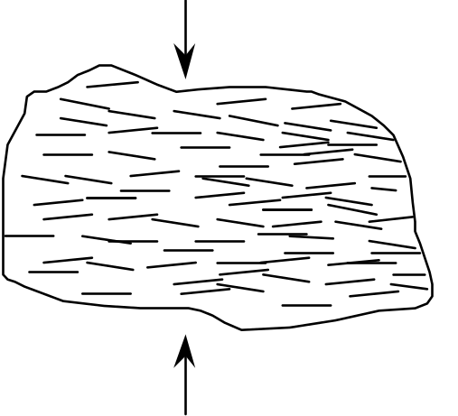

10. There are three basic processes by which crystals can form. One of these processes, which occurs during metamorphism, is the recrystallization of pre-existing crystals. We saw a movie about this process (remember the steel wafer?) but, for logistical reasons, we didn't actually make crystals in class by this process. We did, however, make crystals using the other two basic processes.
Describe the two processes that we used to make crystals in class. Which is an igneous process? Which is a sedimentary process? For each process, give an example of a specific rock type whose crystals formed by that process.
Process #1: we cooled melted salol until it crystallized. This is an igneous process because the liquid that we started out with was liquid because it was above its melting temperature. Crystallization happened when the liquid cooled to a temperature below its melting temperature. Granite is an example of a rock that forms by this process.
Process #2: we let the water evaporate out of a solution of alum in water--the alum crystallized. This is a sedimentary process because the crystals formed only when the water evaporated. The liquid that we started out with was NOT above the melting temperature of alum. Rather, the alum was dissolved in water. Most of the liquid was actually water, not alum. Rock salt is an example of a rock that forms by this process.

11. Does water have to evaporate for limestone to form. If so, why? If not, describe how limestone can form without the evaporation of water.
You can form limestone by evaporating hard water, but evaporation is not necessary for the formation of limestone. In fact, very little limestone is formed as a result of evaporation. Almost all limestone forms when living organisms extract calcium carbonate out of the water to make their “hard parts” (e.g. skeletons or shells). When these organisms die, their hard parts settle to the bottom of the ocean, forming a layer. Eventually, these hard parts are compacted and cemented together to form the hard rock called limestone.

Igneous petrologists (geologists who study igneous processes and rocks) care a great deal about these feldspars but you don’t have to, so don’t worry about the calcium/sodium content of minerals. You can ignore the calcium/sodium content of the feldspars; just realize that feldspar can crystallize over a very wide range of temperatures.
Note that the composition of a melt can be a little different from the composition of the parent rock (the rock that melted), but not wildly different. The composition of the melt may be one “step” (on the Bowen's reaction series chart) above or below the composition of the parent rock, but not two or three steps.
* An outcrop is an exposure of solid rock “in place” at the earth's surface. It is not loose; it is anchored to the bedrock that is always present (but usually invisible) under the soil and vegetation we more typically see on the earth's surface.
*The symbols to use are < (less than), > (greater than), or = (equal to).
Confining pressure in Earth’s crust is analogous to air pressure in the atmosphere, as we shall see later this semester. Air pressure is a function of the amount of air above you. Therefore, the higher you go in the air, the lower the air pressure.
* There are multiple examples of some minerals; you WILL NOT be asked to distinguish among multiple examples of the same mineral. We gave you several examples of some minerals so that you could see some of the variety within those mineral types.
This laboratory activity was modified from a) The River Cutters unit of the Great Explorations in Math and Science (GEMS) curriculum materials for Grades 6–9, published in 1989 by the Lawrence Hall of Science, University of California at Berkeley. b) The Stream Tables activity of the Landforms Module of the Full Option Science System (FOSS) curriculum materials for grades 5–6, published in 1990 by the Lawrence Hall of Science, University of California at Berkeley; distributed by Encyclopaedia Brittanica.
A tributary is a side stream that joins the main stream (which is called the trunk stream). These terms derive from the resemblance between river systems and trees. See, for example, Figure 5.4 on p. 119 in the textbook; the tributaries are the finer “branches” of the “tree” and the trunk stream is the “trunk” of the “tree.”
In the textbook, read the text on p. 125 and study Figures 5.10 through 5.12 on p. 124–125.
In the textbook, read the text on p. 129 and study Figures 5.19 and 5.20 on p. 129–130.
Foliation is layering in the rock formed when elongate or flat crystals are all lined up the same way.
We use the term “particles” here to mean individual pieces of sediment; an individual particle may be 10 feet across!
We use the term “particles” here to mean individual pieces of sediment; an individual particle may be 10 feet across!

